**HIV/AIDS Epidemiology Report for the**

**Tampa- St. Petersburg Eligible Metropolitan Area**

**2018 - 2019**

Adopted April 3, 2019

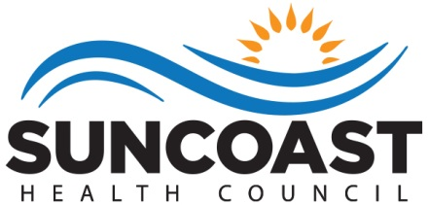

Rob Marlowe, Board Chair

Elizabeth Rugg, Executive Director

Naomi Ardjomand-Kermani, Ryan White Planning Manager **Who We Are**

The health councils were created in 1983 by Florida Statute to identify, address and resolve health care issues of local concern. Each health council is a private, non-profit organization governed by a Board of Directors. The Board members are appointed by County Commissioners to represent the concerns of health care consumers, providers and purchasers.

The Suncoast Health Council, Inc. (SHC) serves Pasco and Pinellas counties. The Council has extensive experience working with for-profit and non-profit agencies, public health organizations, consumers and professionals. Collaboration and cooperation are critical to the success of our mission.

We have three strategic goals: (1) support the accessibility of health care and social support systems through *comprehensive health planning*; (2) obtain and provide *education* about essential community health challenges and solutions; and (3) participate as collaborative partners to develop and sustain efficient and cost effective *service delivery* systems.

**Suncoast Health Council, Inc.**

**Board of Directors**

Rob Marlowe, Acting Chair

Terri Briseno

Dr. Vonda Colquitt

Dr. Larry Floriani

Melissa Johnson

Ginny Nelson

Kimberly Price

Dr. Patricia Quigley

Brittany Peters

Nadine Spring

Trenae Gayle

**To Learn More About the Health Council**

Visit our website - www.SuncoastHealthCouncil.org

Or Contact Us:

Suncoast Health Council, Inc.

9600 Koger Blvd., Suite 221

St. Petersburg, FL 33702

727-217-7070

727-570-3033 (Fax)

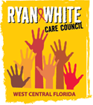

**WEST CENTRAL FLORIDA RYAN WHITE CARE COUNCIL**

Mission Statement

We are a planning body that assesses needs, plans, allocates resources, and evaluates HIV/AIDS services to improve the lives of those infected and affected.

Members

Lisa Conder

Paula Delgado

J. Carl Devine

Dr. Michael Dunn

Nolan Finn

Dr. Tonicia Freeman-Foster

Kirsty Gutierrez

Kayon Henderson

Charlie Hughes

Joyce Johnson

Vincent Kaborycha

Mary Ann Keller

Kamaria Laffrey

Robert Loy

Dr. Amanda Miller

Kimberly Molnar

Michael Moran

Guttenberg Pierre, Jr.

Elliot Rodriguez

Barbara Szelag

Peggy Wallace

Bernard Washington

Produced on behalf of The Ryan White Care Council under contract with the Health Care Services Department within the Human Services of Hillsborough County; Ryan White Program. Funded by HRSA and the State of Florida, Department of Health.

This page is intentionally left blank.

**INTRODUCTION**

The Tampa**-**St. Petersburg Eligible Metropolitan Area (EMA), located on the west central coast of Florida, is comprised of Hernando, Hillsborough, Pasco, and Pinellas Counties. The EMA utilizes Ryan White HIV/AIDS Program (RWHAP) Part A grant funds in support of a comprehensive continuum of high-quality care and treatment for people living with HIV/AIDS (PLWHA) in the service area.

The purpose of this project is to achieve the goals as defined in the National HIV/AIDS Strategy (NHAS) and to facilitate, support, and execute the mission of the West Central Florida Ryan White Care Council (herein referred to as Planning Council): *The Care Council is a planning body (of dedicated volunteers) that assesses needs, plans, allocates resources, and evaluates HIV/AIDS services to improve the lives of those infected and affected.*

**Epidemiologic Overview**

The Tampa-St. Petersburg Eligible Metropolitan Area (EMA)’s total population is approximately 2.9 million, of which 66% are White (non-Hispanic), 17% are Hispanic and 12% are Black (non-Hispanic). Women represent 51.4% of the total population. The image below depicts the geographic layout of the EMA.

Tampa-St. Petersburg EMA

Geographic Layout



The following data provides a description of the sociodemographic, geographic, behavioral, and clinical characteristics of persons newly diagnosed with HIV, persons living with HIV, and persons at higher risk for infection. This information is used by the local area to set priorities, identify interventions and services, and to allocate resources to HIV prevention and care. This epidemiologic overview focuses on the most recent year for which data is available with three year trend data as appropriate.

The socioeconomic status of individuals living in the EMA varies throughout the four county area. In 2015, according to United States Census Bureau, the median household income of residents living in the EMA ranged from $40,945 (Hernando) to $50,579 (Hillsborough), while the median household income of Pinellas is $45,819 and Pasco is $45,064. The percentage of individuals living below the federal poverty level ranges from 14% in Pasco County to 17% in Hillsborough County. The percentage of adults in each county who have any type of health insurance ranges from 80.2% in Pinellas to 87.2% in Hernando. The percentage of EMA residents over the age of 25 with a high school diploma ranges from 37.5% of residents in Hernando County to 27.3% in Hillsborough County. The percentage of persons over the age of 25 who possess a bachelor’s degree or higher ranges from 15.6% in Hernando County to 30.6% in Hillsborough County.

According to the Florida Department of Health’s Epidemiological Profile, **Figure 1** shows that the incidence of HIV in the EMA increased 12% since 2012. New cases of AIDS decreased 23.8% since 2012. The most common mode of transmission for HIV and AIDS in the EMA was men who have sex with men (MSM) followed by heterosexual transmission, and injection drug use (IDU).

**Figure 1: Tampa/St. Petersburg EMA Epidemiological Profile**

|  |  |  |  |  |  |  |
| --- | --- | --- | --- | --- | --- | --- |
|  | **CY 2014** | | **CY 2015** | | **CY 2016** | |
| **Incidence** | **Prevalence** | **Incidence** | **Prevalence** | **Incidence** | **Prevalence** |
| **HIV** | 558 | 5,332 | 566 | 5,538 | 560 | 5,788 |
| **AIDS** | 313 | 6,992 | 287 | 7,030 | 279 | 7,178 |
| **TOTAL** | 871 | 12,324 | 853 | 12,568 | 839 | 12,966 |

Source: Florida Department of Health, Tampa-St. Petersburg EMA Epidemiological Profiles Calendar Year (CY) 2014, 2015, 2016.

**Attachment 1** describes the demographic data of PLWHA in the EMA including race, age, sex, and transmission category.

The most common mode of transmission for newly diagnosed individuals living with HIV/AIDS from 2014-2016 was MSM with 465 new cases of AIDS and 1,076 new cases of HIV. Heterosexual contact accounted for 287 new AIDS cases and 438 new HIV cases. IDU transmission was the third highest mode of transmission with 102 HIV cases and 83 AIDS cases.

The incidence of HIV among males in the EMA increased from 432 cases in 2014 to 446 cases in 2016; a 3.2% increase. During the same time frame, new HIV cases among females decreased by 9.6% from 125 to 113. The incidence of male AIDS cases decreased 10.8%, from 313 to 279 cases. The incidence of female AIDS cases decreased 31.2% from 2014-2016; 80 to 55 cases.

Source: Florida Department of Health, Tampa-St. Petersburg EMA Epidemiological Profiles CY 2014, 2015, 2016.

As shown in **Figure 2**, over the past three years there has been an increase in the incidence of HIV in the EMA for Whites and Hispanics. The HIV incidence rose 1% and 9.6% respectively. From 2014 to 2016, the incidence of AIDS decreased among White, Black, and Hispanic populations in the EMA, as seen in **Figure 3**. The incidence of AIDS among Blacks in the EMA decreased 17%, while the incidence of HIV among Blacks decreased by 12% from 2014-2016.

The 2016 calendar year saw minor demographic changes in HIV and AIDS prevalence. Whites in the EMA represented two thirds of the population and had the highest percentage of HIV cases at 44%. Blacks accounted for 37% and Hispanics represented 17% of HIV cases. Whites represented the largest prevalence of AIDS cases in the EMA with 47%, followed by Blacks with 35% and Hispanics with 16%. Blacks were disproportionately impacted by HIV/AIDS. Blacks made up only 12% of the population in the EMA in 2016 and represented 37% of HIV cases and 35% of the AIDS cases.

In 2016, men represented 74.7% and 75.6% of HIV and AIDS prevalence respectively. In the EMA, men comprise approximately 48.6% of the population but represent a majority of HIV and AIDS cases. Women represented 25.3% and 24.4% of HIV and AIDS cases respectively.

Overall, there has been an increase in HIV/AIDS prevalence in every race and ethnicity category in the last three years. Hispanics in the EMA saw the greatest increase in HIV/AIDS prevalence from 1,931 cases in 2014 to 2,161 cases in 2016.

There were 4,633 Black PLWHA in the EMA in 2016. Approximately 31.5% of PLWHA in this racial group are aware of their status and not in care (unmet need). There were 2,161 Hispanic PLWHA in the EMA in 2016. Approximately 27.9% of PLWHA in this ethnic group are aware of their status and not in care (unmet need). There were 5,869 White PLWHA in the EMA in 2016. Approximately 27.0% of PLWHA in this racial group are aware of their status and not in care (unmet need).

The CDC estimates that 15.6% of Florida’s population is unaware of their HIV status. In the past the EMA applied CDC’s estimate in order to determine unmet need. This year, the EMA was discouraged by the Florida Department of Health (FDOH) from using these calculations to represent smaller population areas.

**Figure 4** depicts the presumed living HIV/AIDS cases in each of the EMA’s four counties as of 6/30/2017. The EMA’s urban counties (Hillsborough and Pinellas) experienced a greater number of HIV/AIDS cases compared to the rural counties (Hernando and Pasco).

**Figure 4:**

**Tampa-St. Petersburg EMA**

**HIV/AIDS Cases per County**

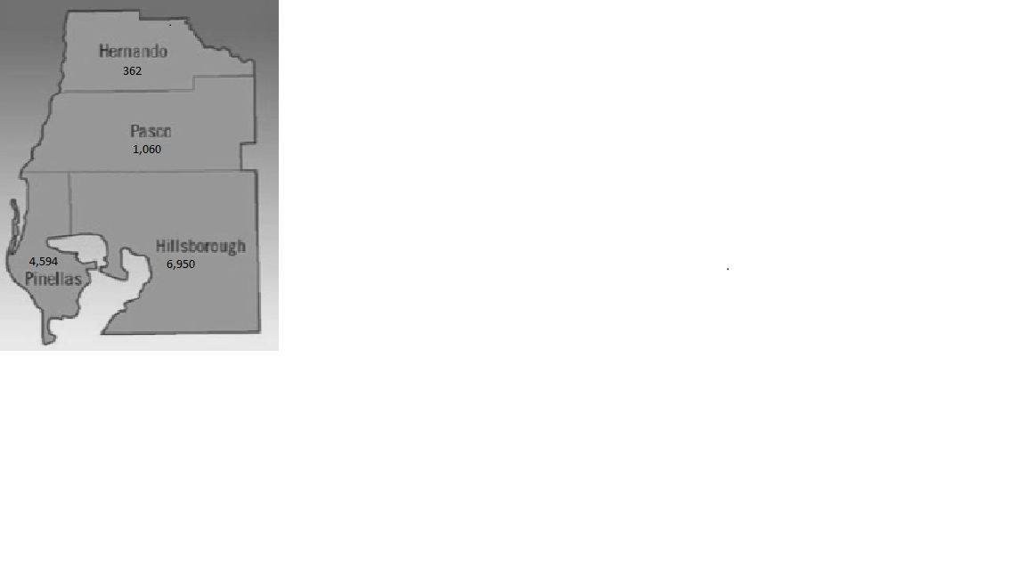

Source: Florida Department of Health, Epidemiological Profile, EMA Report, August 2017.

Sociodemographic indicators of PLWHA in the EMA were assessed through data reporting and client needs assessment surveys. The 2016 Client Needs Survey omitted questions regarding unemployment and insurance. Overall, the 2016 Needs Survey did not receive enough responses, in the EMA, for the data to be generalizable. As a result, the results from the 2013 Client Needs Survey are still in use for planning purposes. According to the 2013 Client Survey, the PLWHA population in the EMA has an unemployment rate of 65%, and 41.5% of PLWHA are without insurance. Of the clients receiving Part A funded services who reported their incomes, 96.9% reported incomes less than 300% of the Federal Poverty Level (FPL), 80% report incomes less than 200% FPL and 59.9% reported incomes of less than 100% FPL.

Additional socioeconomic data for PLWHA in the EMA, including percentage of federal poverty level and health insurance status, is included in the Complexities of Providing Care section of this application.

The Planning Council identifies and monitors populations highly impacted by HIV/AIDS on a continual basis through its committees. The EMA has seen a rise in HIV infections in youth specifically among males and youth of color. The Florida Department of Health’s 2016 Epidemiological Profile reports the infection rate for Black Female Youth (ages 13-24) increased 50% in the EMA between calendar year 2012 and calendar year 2016. The HIV infection rate for Hispanic Male Youth (ages 13-24) increased 80% from 2012 to 2016. Concurrently, the prevalence of HIV infection among White Male Youth (ages 13-24) decreased 3% and White Female Youth (ages 13-24) decreased 25%.

Unique challenges for this population include social, economic, and cultural barriers that limit access to prevention and care. Stigma and misinformation about HIV and AIDS are also contributing factors for the disproportionality high rates of HIV among youth. Low rates of condom use, substance abuse, and engaging in sexual activity with older partners are prevention challenges for this emerging population. Youth are more likely to forego needed health care due to lack of access to transportation, fear, lack of insurance, and disapproval from family and peers. Service delivery for this emerging population is coordinated through partnerships among EMA community providers, Recipient-funded services, Part B and D funds, as well as Medicaid.

The Florida Department of Health’s 2016 Epidemiological Profile reports 29% (n=3,810) of PLWHA aware of their status in the EMA were not retained in medical care. Populations in the EMA that are Ryan White eligible and under-represented in care include: White Women of Childbearing Age (WCBA), Black WCBA, and Black Male Youth. Respectively, 41% (n=106) of White WCBA, 36.3% (n=263) of Black WCBA, and 31% (n=65) of Black Male Youth were not retained in medical care in 2016. The EMA’s 2016 care continuum by population also shows that 81% (n=38) of homeless PLWHA in the EMA were not retained in care. Retained in care is defined as receiving medical care two or more times in a year, at least three months apart.

Blacks and Hispanics were chosen as MAI populations of focus due to their under-representation in the Ryan White system of care and the lower than expected number of PLWHA retained in care. In 2016, 1,461 (32%) Black PLWHA and 602 (28%) Hispanic PLWHA in the EMA were not retained in medical care.

See **Attachment 2** for co-occurring conditions among all PLWHAS in the Tampa-St. Petersburg EMA.

**THE EPIDEMIC BY AREA**

The State of Florida is broken down into numbered areas. The West Central Florida Ryan White Care Council covers three areas: Area 5, Area 6, and Area 14. The data is not available by county, only by area or EMA. In an effort to provide information regarding all the areas covered by the Care Council and not just the EMA, **Figures 5, 6**, **and 7** represent the three geographic areas that make up the Total Service Area (TSA).

**Figure 5: Area 5 includes Pasco and Pinellas Counties**

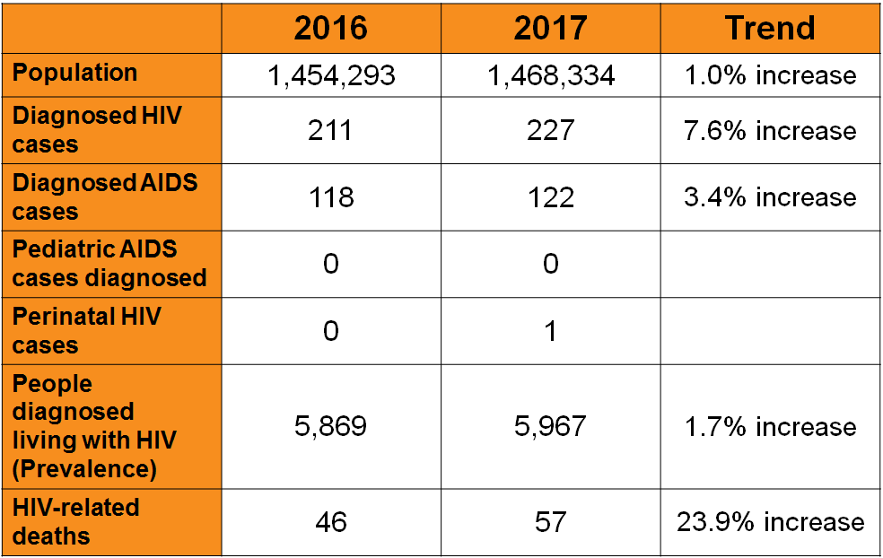

Source: Florida Department of Health, HIV/AIDS Section, 2017.

**Figure 6: Area 6 includes Hernando, Hillsborough, and Manatee Counties**

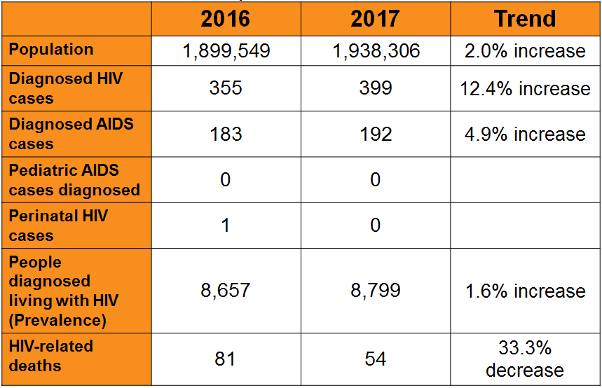

Source: Florida Department of Health, HIV/AIDS Section, 2017.

**Figure 7: Area 14 includes Hardee, Highlands, and Polk Counties**

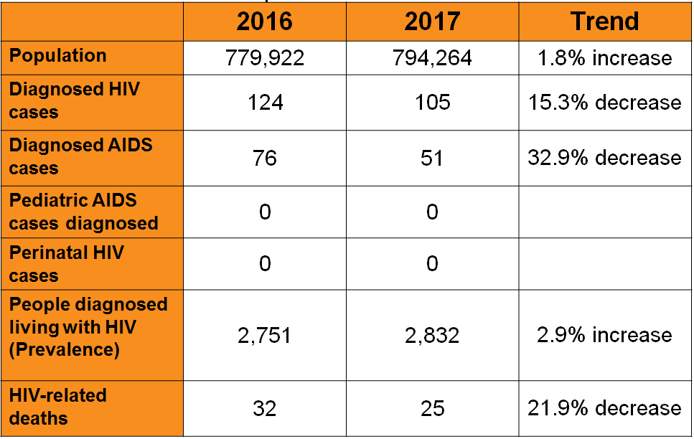

Source: Florida Department of Health, HIV/AIDS Section, 2018.

**ACKNOWLEDGMENTS**

The West Central Florida Ryan White Care Council wishes to recognize the contributions of the following:

**Planning and Evaluation Committee Members**

Kirsty Gutierrez, Chair

Sheryl Hoolsema, Co-Chair

Nolan Finn

Charlie Hughes

Marylin Merida

Jim Roth

Elizabeth Rugg

**Other Contributors**

Lorene Maddox, Florida Department of Health, Bureau of Communicable Disease, HIV/AIDS Section

**AIDS and HIV Prevalence Data by Demographic Group and Exposure Category**

Attachment 1

|  |  |  |  |  |  |  |
| --- | --- | --- | --- | --- | --- | --- |
| **Demographic Group/**  **Exposure Category** | **2015- Prevalence as of 12/31/15** | | **2016-PREVALENCE AS OF 12/31/16** | | **2017-PREVALENCE AS OF**  **12/31/17** | |
| ***Race/Ethnicity*** | **HIV** | **AIDS** | **HIV** | **AIDS** | **HIV** | **AIDS** |
| White, not Hispanic | 2,459 | 3,307 | 2,525 | 3,344 | 2,661 | 3,387 |
| Black, not Hispanic | 2,025 | 2,473 | 2,132 | 2,501 | 2,312 | 2,702 |
| Hispanic | 933 | 1,095 | 995 | 1,166 | 1,062 | 1,219 |
| Other / Unknown | 121 | 1,550 | 136 | 167 | 149 | 175 |
| **Total** | 5,538 | 7,030 | 5,788 | 7,178 | 6,184 | 7,437 |
| ***Gender*** | **HIV** | **AIDS** | **HIV** | **AIDS** | **HIV** | **AIDS** |
| Male | 4,113 | 5,273 | 4,321 | 5,425 | 4,656 | 5,692 |
| Female | 1,425 | 1,757 | 1,467 | 1,753 | 1,528 | 1,791 |
| **Total** | 5,538 | 7,030 | 5,788 | 7,178 | 6,184 | 7,437 |
| ***Current Age as of Reporting Year*** | **HIV** | **AIDS** | **HIV** | **AIDS** | **HIV** | **AIDS** |
| <13 years | 13 | 4 | 13 | 3 | 13 | 3 |
| 13 - 24 years | 359 | 127 | 363 | 102 | 343 | 93 |
| 25 - 44 years | 2,362 | 1,755 | 2,413 | 1,716 | 2,608 | 1,758 |
| 45 - 59 years | 2,131 | 3,844 | 2,246 | 3,890 | 2,341 | 3,946 |
| 60+ years | 673 | 1,300 | 753 | 1,467 | 879 | 1,683 |
| **Total** | 5,538 | 7,030 | 5,788 | 7,178 | 6,184 | 7,437 |
| ***Exposure Category*** | **HIV** | **AIDS** | **HIV** | **AIDS**  **HIV**  **AIDS** |  |  |
| Men who have sex with men | 3,289 | 3,697 | 3,469 | 3,808 | 3,734 | 3,972 |
| Injection drug users | 394 | 742 | 385 | 742 | 420 | 756 |
| Men who have sex with men and inject drugs | 231 | 417 | 247 | 416 | 257 | 453 |
| Heterosexuals | 1,560 | 2,046 | 1,618 | 2,079 | 1,704 | 2,168 |
| Other/Unknown | 53 | 125 | 56 | 129 | 56 | 131 |
| **Total** | 5,527* | 7,027* | 5,775* | 7,174* | 6,184 | 7,480* |

Source: Florida Department of Health EMA Epidemiological Profiles CY 2015; CY 2016; CY 2017

*Risk data are calculated values from a weighted database to redistribute the NIRs into known risks. Therefore, some risk data was off from the total due to rounding issues, according to the Florida Department of Health.

**Co-occuring Conditions**

Attachment 2

**Tampa-St. Petersburg EMA**

|  |  |  |
| --- | --- | --- |
| **Co-occurring Condition** | **Co-occurring condition in PLWHA Population within EMA** | **Data Source** |
| **Infectious Syphilis** (diagnosed among HIV/AIDS patients in 2017) | 22.2* | PRISM (Patient Reporting, Investigation and Surveillance Manager)  Data through 2017 |
| **Gonorrhea** (diagnosed among HIV/AIDS patients in 2017) | 23.9* | PRISM (Patient Reporting, Investigation and Surveillance Manager)  Data through 2017 |
| **Chlamydia** (diagnosed among HIV/AIDS patients in 2017) | 16.8* | PRISM (Patient Reporting, Investigation and Surveillance Manager)  Data through 2017 |
| **Hepatitis C** (diagnosed among HIV/AIDS patients in 2017) | 5.5* | MERLIN Data through 2017 |
| **Homelessness** (based on current address type at the end of 2017 being labeled as Homeless, Shelter, Temporary, or zip code 99999) | 4.4* | Florida eHARS (enhanced HIV/AIDS Reporting System)  Data through 2017 |
| **Substance Abuse** (any living HIV/AIDS case noted with a history of substance abuse, e.g. alcohol, methamphetamine, cocaine, inhalants, etc.) | 274.1* | Florida eHARS (enhanced HIV/AIDS Reporting System)  Data through 2017 |
| **Chronic Mental Illness** (any HIV/AIDS case noted with a history of mental illness as documented in eHARS) | 84.7* | Florida eHARS (enhanced HIV/AIDS Reporting System)  Data through 2017 |
| **Formerly Incarcerated** (HIV positive Florida Department of Corrections offenders released to the EMA in 2017) | 7.0* | Department of Corrections Offender-based Information System  Data for Calendar Year 2017 |

Source: Florida Department of Health EMA Epidemiological Profiles CY 2015; CY 2016; CY 2017

*Rate per 1,000 persons living with HIV/AIDS in the Tampa-St. Petersburg EMA

Risk data are calculated values from a weighted database to redistribute the NIRs into known risks. Therefore, some risk data was off by one or two cases from the total due to rounding issues, according to the Florida Department of Health.