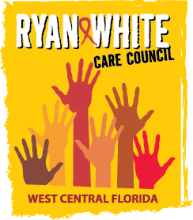
WEST CENTRAL FLORIDA RYAN WHITE CARE COUNCIL
COMMUNITY ADVISORY COMMITTEE
HILLSBOROUGH COUNTY HEALTH DEPARTMENT - TAMPA
THURSDAY, JANUARY 28, 2016
2:00 P.M. - 3:30 P.M.

AGENDA
- Call to Order Chair

- Roll Call Staff

- Changes to Agenda Members

- Adoption of Minutes Chair
October 22, 2015 (Attachment)

- Care Council Report Co-Chair

- Client Satisfaction Survey Members

- Participation Development Members

- Client Input Members

- Announcements Members/Guests
- Adjournment Chair

Note: Items in bold are action items.

The next meeting of the Ryan White Care Council will be March 2, 2015 from 1:30pm to 3:30pm, at the Children’s Board of Hillsborough County.

The CARE COUNCIL website is operating at www.thecarecouncil.org. Agendas and minutes will be posted on this website.

