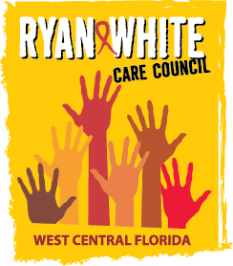
WEST CENTRAL FLORIDA RYAN WHITE CARE COUNCIL
COMMUNITY ADVISORY COMMITTEE
HILLSBOROUGH COUNTY HEALTH DEPARTMENT - TAMPA
Thursday February 26, 2015
2:00 P.M. - 3:30 P.M.

AGENDA
- Call to Order Chair

- Roll Call Staff

- Changes to Agenda Members

- Adoption of Minutes Chair
January 22, 2014 (Attachment)

- Care Council Report Co-Chair

- Client Survey Review Members

- Community Input Members

- Announcements Members/Guests
- Adjournment Chair

Note: Items in bold are action items.

The next meeting of the Ryan White Care Council will be March 4, 2015 from 1:30 pm to 3:30 pm, at the Children’s Board of Hillsborough County.

The CARE COUNCIL website is operating at www.thecarecouncil.org. Agendas and minutes will be posted on this website.

