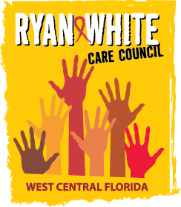

WEST CENTRAL FLORIDA RYAN WHITE CARE COUNCIL
MEMBERSHIP, NOMINATIONS, RECRUITMENT, AND TRAINING COMMITTEE
METRO WELLNESS & COMMUNITY CENTER - TAMPA
MONDAY, OCTOBER 19, 2015
11:00 A.M. - 12:30 P.M.

AGENDA
- Call to Order Chair

- Roll Call Staff

- Changes to Agenda Members

- Adoption of Minutes (Attachments) Chair
September 28, 2015

- Care Council Report Chair

VII. Membership Report Chair

XII. Membership Orientation Chair/Members

XIII. Membership Retreat Chair/Members

XIV. Membership Outreach Strategies Chair/Members

XV. PR & Marketing Efforts Chair/Members

XVI. Community Concerns/Announcements Chair/Members

XVII. Adjournment Chair

Note: Items in bold are action items.

The next meeting of the Ryan White Care Council will be November 4, 2015 from 1:30pm to 3:30pm, at the Children’s Board of Hillsborough County.

The CARE COUNCIL website is at www.thecarecouncil.org. Meeting information, agendas and minutes will be posted on this website.

