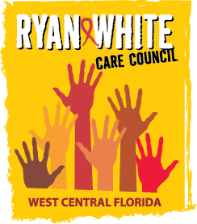

WEST CENTRAL FLORIDA RYAN WHITE CARE COUNCIL
MEMBERSHIP, NOMINATIONS, RECRUITMENT, AND TRAINING COMMITTEE
METRO WELLNESS & COMMUNITY CENTER - TAMPA
MONDAY, FEBRUARY 8, 2016
11:00 A.M. - 12:30 P.M.

AGENDA
- Call to Order Chair

- Roll Call Staff

- Changes to Agenda Members

- Adoption of Minutes (Attachments) Chair
November 16, 2015
January 11, 2016

- Care Council Report Chair

VI. Membership Report Chair

VII. Membership Review / New Member Applications Chair/Members

VIII. Bylaw Review Chair/Members

IX. Membership Outreach Strategies Chair/Members

X. PR & Marketing Efforts Chair/Members

XI. Community Concerns/Announcements Chair/Members

XII. Membership Training Chair

XIII. Adjournment Chair

Note: Items in bold are action items.

The next meeting of the Ryan White Care Council will be March 2, 2016 from 1:30pm to 3:30pm, at the Children’s Board of Hillsborough County.

The CARE COUNCIL website is at www.thecarecouncil.org. Meeting information, agendas and minutes will be posted on this website.

