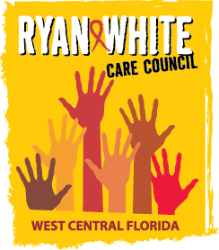

WEST CENTRAL FLORIDA RYAN WHITE CARE COUNCIL
MEMBERSHIP, NOMINATIONS, RECRUITMENT, AND TRAINING COMMITTEE
CHILDREN’S BOARD OF HILLSBOROUGH COUNTY
WEDNESDAY, MARCH 2, 2016
1:00 P.M. - 1:30 P.M.

AGENDA

- Call to Order Chair

- Roll Call Staff

- Adoption of Minutes (Attachments) Chair
November 16, 2015
January 11, 2016

IV. Membership Review / New Member Applications Chair/Members

V. Adjournment Chair

Note: Items in bold are action items.

The next meeting of the Ryan White Care Council will be March 2, 2016 from 1:30pm to 3:30pm, at the Children’s Board of Hillsborough County.

The CARE COUNCIL website is at www.thecarecouncil.org. Meeting information, agendas and minutes will be posted on this website.

