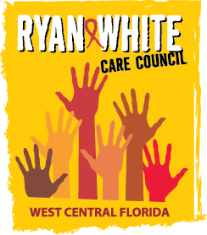
WEST CENTRAL FLORIDA RYAN WHITE CARE COUNCIL
MEMBERSHIP, NOMINATIONS, RECRUITMENT, AND TRAINING COMMITTEE
METRO WELLNESS & COMMUNITY CENTER - TAMPA
MONDAY, APRIL 13, 2015
11:00 A.M. - 12:30 P.M.

AGENDA
- Call to Order Chair

- Roll Call Staff

- Changes to Agenda Members

- Adoption of Minutes Chair
March 16, 2015 (Attachment)

- Care Council Report Chair

- Membership Review Chair

- Membership Nomination (Attachment) Members
  - #15-05

VII. Membership Retreat Members

- Membership Outreach Strategies Chair/Members

- Community Concerns/Announcements Chair/Members

- Adjournment Chair

Note: Items in bold are action items.

The next meeting of the Ryan White Care Council will be May 6, 2015 from 1:30 pm to 3:30 pm, at the Children’s Board of Hillsborough County.

The CARE COUNCIL website is at www.thecarecouncil.org. Meeting information, agendas and minutes will be posted on this website.

