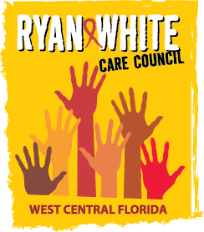

WEST CENTRAL FLORIDA RYAN WHITE CARE COUNCIL
MEMBERSHIP, NOMINATIONS, RECRUITMENT, AND TRAINING COMMITTEE
METRO WELLNESS & COMMUNITY CENTER - TAMPA
MONDAY, APRIL 18, 2016
11:00 A.M. - 12:30 P.M.

AGENDA
- Call to Order Chair

- Roll Call Staff

- Changes to Agenda Members

- Adoption of Minutes (Attachments) Chair
March 21, 2016

- Care Council Report Chair

VI. Membership Report/ Attendance Chair

- Membership Application Scoring Chair/Members

- Bylaw Review Chair/Members

- Membership Retreat Chair/Members

VIII. Membership Outreach Strategies/PR & Marketing Efforts Chair/Members

IX. Community Concerns/Announcements Chair/Members

X. Adjournment Chair

Note: Items in bold are action items.

The next meeting of the Ryan White Care Council will be May 4, 2016 from 1:30pm to 3:30pm, at the Children’s Board of Hillsborough County.

The CARE COUNCIL website is at www.thecarecouncil.org. Meeting information, agendas and minutes will be posted on this website.

