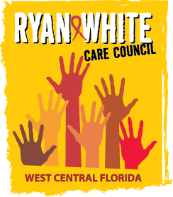
WEST CENTRAL FLORIDA RYAN WHITE CARE COUNCIL
MEMBERSHIP, NOMINATIONS, RECRUITMENT, AND TRAINING COMMITTEE
METRO WELLNESS & COMMUNITY CENTER - TAMPA
MONDAY, JUNE 15, 2015
11:00 A.M. - 12:30 P.M.

AGENDA
- Call to Order Chair

- Roll Call Staff

- Changes to Agenda Members

- Adoption of Minutes (Attachments) Chair
April 13, 2015
May 18, 2015

- Membership Nomination (Attachments) Members
  - #15-05
  - #15-06

IX. Member Orientation Members/Staff

XII. Adjournment Chair

Note: Items in bold are action items.

The next meeting of the Ryan White Care Council will be July 1, 2015 from 1:30 pm to 3:30 pm, at the Children’s Board of Hillsborough County.

The CARE COUNCIL website is at www.thecarecouncil.org. Meeting information, agendas and minutes will be posted on this website.

