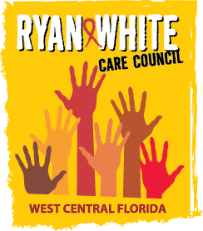

WEST CENTRAL FLORIDA RYAN WHITE CARE COUNCIL
RESOURCE PRIORITIZATION AND ALLOCATION RECOMMENDATIONS
SUNCOAST HOSPICE, CLEARWATER
THURSDAY, NOVEMBER 12, 2015
11:00 A.M. – 12:30 P.M.

MINUTES
CALL TO ORDER | The meeting was called to order by Nolan Finn, Chair at 11:01 a.m.
ATTENDANCE | Members Present: Ginny Boucher, Marty Clemmons, Nolan Finn, Teri Fitzgerald, Brandi Geoit, David Konnerth, Marilyn Merida, Jim Roth, Elizabeth Rugg, Joy Winheim  Members Absent: Carla Baity, William Harper, Priya Rajkumar  Guests Present: Jacquelyn Finch, Nicole Frigel  Recipient Staff Present: Aubrey Arnold  Lead Agency Staff Present: Demarcus Holden, Shelley Taylor-Donahue  Health Council Staff Present: Julie Gnage
CHANGES TO AGENDA | Part B reallocations were added below Part A reallocations.
ADOPTION OF MINUTES | The minutes for October 8, 2015 were approved (M: Fitzgerald, S: Winheim).
CARE COUNCIL REPORT | Dave Konnerth gave the Care Council report for the meeting held on November 4, 2015.  The group discussed the findings of the Assessment of Administrative Mechanism (AAM) report. An update was provided by Aubrey Arnold on the new sub-recipient database, E2. The membership committee also presented their youth retreat at the November Care Council meeting. The presentation was facilitated by Bernard Washington.  The next Care Council meeting will be held on December 2, 2015.
PART A REALLOCATIONS | Aubrey Arnold presented the Part A Reallocation Recommendations totaling $330,000. The recommendations are based on the results of a survey issued to all of the providers and the previous utilization of funds. The recommendation for the reallocation of $330,000 is detailed below:  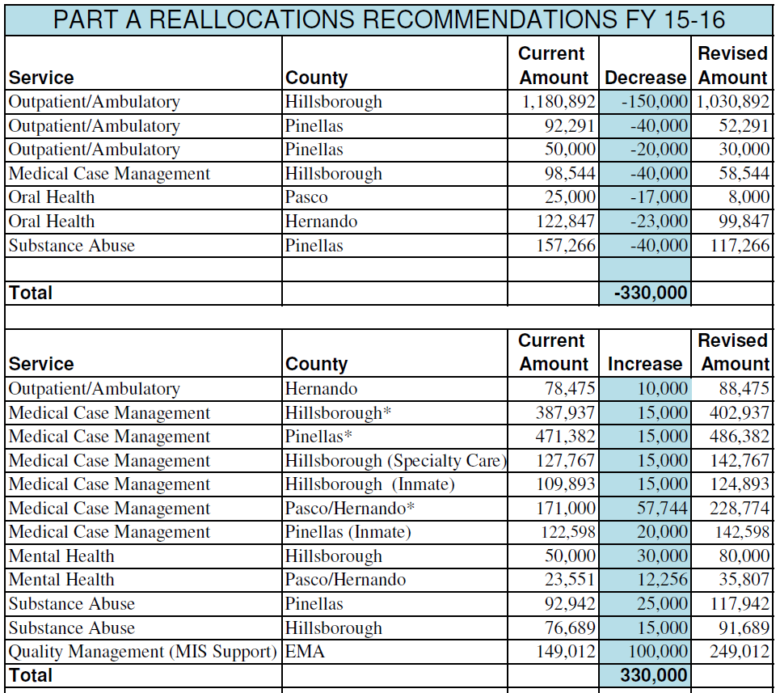  Members discussed proposed allocations and their priority ranking. It was noted that not all top ranking core services submitted a request for additional funding. The reallocation recommendations were approved with 9 yes, 0 nay, 0 abstentions (M: Geoit S: Fitzgerald).  Members discussed that when service priority lists are being decided on, the Planning and Evaluation committee should consider past reallocations.
PART B REALLOCATIONS | Demarcus Holden presented Part B Reallocation Recommendations totaling $33,347. The recommendation for the reallocation of $33,347 is detailed below:  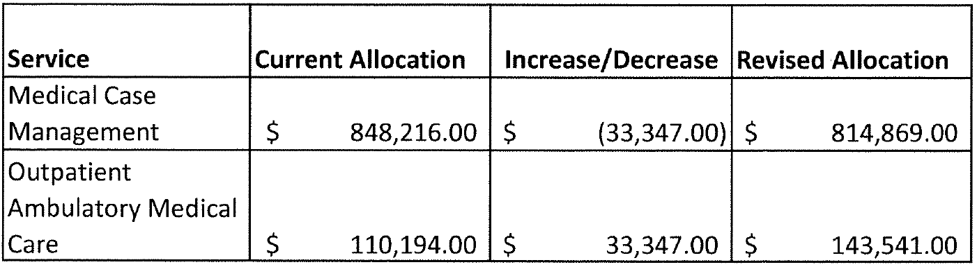  The reallocation recommendations were approved with 9 yes, 0 nay, 0 abstentions (M: Geoit S: Fitzgerald).
PART A CARRYOVER | Aubrey Arnold presented the Part A Carryover Recommendations totaling $97,256. The recommendation for carry over allocation of $97,256 is:  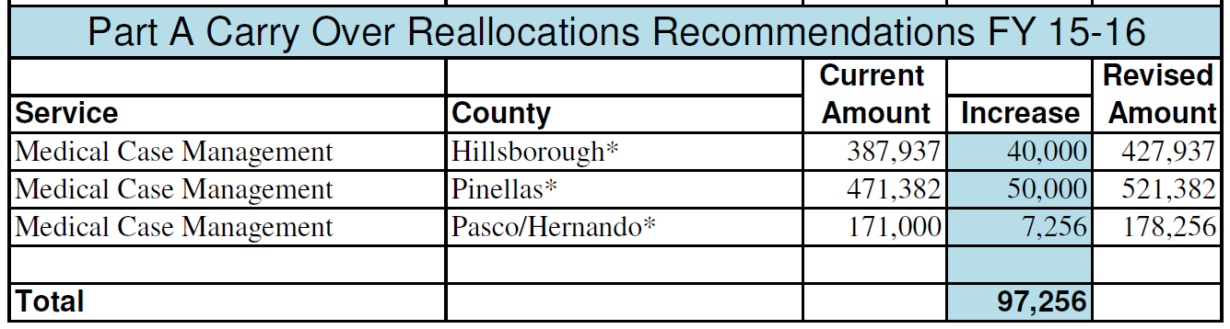  The carryover recommendations were approved with 9 yes, 0 nay, 0 abstentions (M: Geoit S: Merida).
AFFORDABLE CARE ACT/ADAP UPDATE | Aubrey Arnold announced that open enrollment has begun and plans have been vetted by the state and are out. Further announcements about these plans will be made at the providers meeting on Friday, November 13, 2015.  The group also discussed the possibility of seeing a local impact on insurance due to the increase of copays and premiums in January for many Affordable Care Act plans.  Chair, Nolan Finn presented an article from the body.com that referenced possible cuts to the ADAP program nationwide.  Members discussed issues of retention and keeping persons living with HIV in-care.
COMMUNITY INPUT | The AIDS Walk will take place on December 12th. Teams can now register.  World AIDS day is on December 1st, be sure to look out for local events and share them accordingly.
ADJOURNMENT | There being no further business to come before the committee, the meeting was adjourned at 12:02 p.m.

