WEST CENTRAL FLORIDA RYAN WHITE CARE COUNCIL
RESOURCE PRIORITIZATION AND ALLOCATION RECOMMENDATIONS
SUNCOAST HOSPICE, CLEARWATER
THURSDAY, MARCH 10, 2016
11:00 A.M. – 12:30 P.M.

MINUTES
CALL TO ORDER | The meeting was called to order by Nolan Finn, Chair at 11:01 a.m.
ATTENDANCE | Members Present: Ginny Boucher, Nolan Finn, Nicole Frigel, Brandi Geoit, David Konnerth, Marilyn Merida, Priya Rajkumar, Elizabeth Rugg, Joy Winheim  Members Absent: Carla Baity, Marty Clemmons, William Harper, Jim Roth,  Guests Present: Vicky Oliver  Recipient Staff Present: Aubrey Arnold, Onelia Pineda  Lead Agency Staff Present: Shelley Taylor-Donahue, Demarcus Holden  Health Council Staff Present: Samantha Church
CHANGES TO AGENDA | There were no changes to the agenda at this time.
ADOPTION OF MINUTES | The minutes for December 10, 2015 were approved (M: Winheim, S: Geoit).
CARE COUNCIL REPORT | Dave Konnerth gave the Care Council report for the meeting held on March 2, 2016.  Aubrey Arnold notified the group that the recipient’s office received a partial new grant award on February 11th for fiscal year (FY) 2016. The office received $5,456,843. The recipient expects to receive the outstanding grant balance by April or May. Demarcus Holden notified the group that Tallahassee has approved Part B’s FY 2016 budget with a 10% increase. Funding increased from $1,989,530 to $2,188,483, which is about a $200,000 increase.  The Membership Committee recommended removal of Dr. Barry Rodwick due to poor attendance. The motion passed by acclamation. The Planning and Evaluation Committee recommended approval of the Epidemiologic Overview, Care Continuum, Data, and Financial and Human Resources Inventory pieces of the CDC/HRSA Integrated Plan. The pieces were all approved by acclamation.  Jim Roth notified the group that Bill 242, a proposed Miami/Dade needle exchange program, was passed by both the House and Senate and will be sent to the Governor for final approval.
ASSESSMENT OF THE ADMINISTRATIVE MECHANISM-PART B | David Cavalleri presented the Part B Assessment of the Administrative Mechanism (AAM) report. He reminded members that the Part B AAM is not legislatively mandated, but is utilized as a tool to improve the Part B administrative process based on responses from Care Council and provider feedback. The AAM recommendation is to continue to work to inform and communicate with Care Council and providers about activities that are going on within the department. It was also recommended that Care Council should be consulted in advance about Part B resource allocations and reallocations. Demarcus Holden thanked the Department’s contract managers and informed the group that the Lead Agency will try to improve their process based on the AAM responses.  David also provided a Quality Management update. He informed the group that the initial wait time to access outpatient ambulatory medical care (OAMC) is 8 days. He noted that he is also working on pulling data from Part A and Part B clients to create a Ryan White-funded care continuum for the EMA.
PART A AND PART B EXPENDITURE REPORT | Aubrey Arnold and Onelia Pineda presented the Part A Expenditure Report for March 2015 – February 2016. They informed the group that some invoices from February 2016 are not captured in the report as they have not received invoices from some of the providers yet. All outstanding invoices and the summary of all expenditures will be fully closed by May.  Demarcus Holden presented the Part B Expenditure Report reflecting April 2015 - December 2015. All contracts are on target.
PART B ALLOCATION RECOMMENDATION | The Lead Agency was granted a 10% funding increase for FY16-17. The funding amounts to a $198,953 additional award. Demarcus Holden presented the following allocation recommendation: 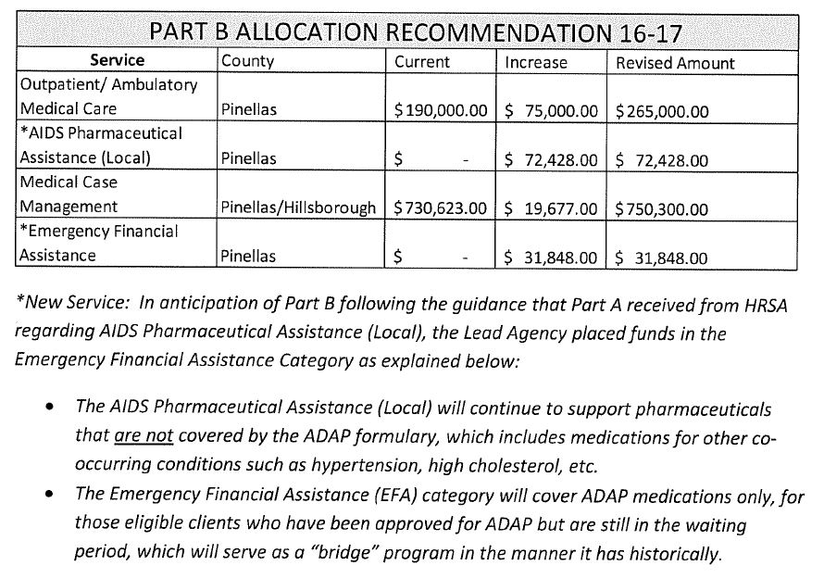  The group discussed that the AIDS Pharmaceutical Assistance (Local) funding and the Emergency Financial Assistance funding would go towards a pilot program. If the pilot works well, Part B will request for proposals (RFP) next year. The pharmacy program will be located in Pinellas. Brandi Geoit seconded the motion. The motion passed by acclamation.
AFFORDABLE CARE ACT/ADAP UPDATE | The group discussed several difficult insurance cases they were dealing with recently. Some insurance companies are not allowing third party payments.
COMMUNITY INPUT | The local ADAP office is planning on creating a database that will allow providers to view when premiums are paid, when the check for the premium was sent, etc. The system will also text clients when refills are sent. The system is anticipated to launch in September.  E2 Hillsborough will launch on June 1st. Part A needs additional time for testing and database training for providers.
ADJOURNMENT | There being no further business to come before the committee, the meeting was adjourned at 12:29 p.m.

