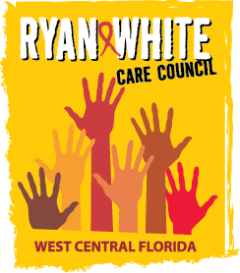
WEST CENTRAL FLORIDA RYAN WHITE CARE COUNCIL
RESOURCE PRIORITIZATION AND ALLOCATION RECOMMENDATIONS
SUNCOAST HOSPICE, CLEARWATER
THURSDAY, May 12, 2016
11:00 A.M. - 12:30 P.M.

AGENDA

- Call to Order Chair

- Roll Call Staff

- Changes to Agenda Members

- Adoption of Minutes Chair
March 10, 2016 (Attachment)

- Care Council Report Co-Chair

- Part A Assessment of the Administrative Mechanism (AAM)
Methodology Cavalleri

VII. Standards, Issues and Operations Committee (SIOC) Members
Discussion

VIII. Community Input/Announcements Chair/Members

IX. Adjournment Chair

Note: Items in bold are action items.

The Ryan White Care Council’s next meeting will be June 1, 2016 at the Children’s Board of Hillsborough County from 1:30pm-3:30pm.

The CARE COUNCIL website is at www.thecarecouncil.org. Meeting information, agendas and minutes will be posted on this website. Check out the Care Council’s Facebook page at www.facebook.com/WestCentralFLRWCC

