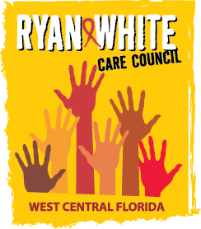
WEST CENTRAL FLORIDA RYAN WHITE CARE COUNCIL
RESOURCE PRIORITIZATION AND ALLOCATION RECOMMENDATIONS
SUNCOAST HOSPICE, CLEARWATER
THURSDAY, NOVEMBER 10, 2016
11:00 A.M. - 12:30 P.M.

AGENDA

- Call to Order Chair

- Roll Call Staff

- Changes to Agenda Members

- Adoption of Minutes Chair
September 8, 2016 (Attachment)

- Care Council Report Co-Chair

- Final Committee Work Plan (Attachment) Members

- Assessment of the Administrative Mechanism Findings Cavalleri

VI. Community Input/Announcements Chair/Members

VII. Adjournment Chair

Note: Items in bold are action items.

The Ryan White Care Council’s next meeting will be December 7, 2016 at the Children’s Board of Hillsborough County from 1:30pm-3:30pm.
The CARE COUNCIL website is at www.thecarecouncil.org. Meeting information, agendas and minutes will be posted on this website.

