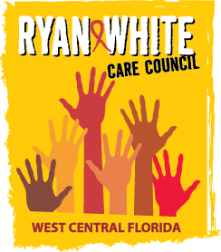
WEST CENTRAL FLORIDA RYAN WHITE CARE COUNCIL
RESOURCE PRIORITIZATION AND ALLOCATION RECOMMENDATIONS
SUNCOAST HOSPICE, CLEARWATER
THURSDAY, SEPTEMBER 8, 2016
11:00 A.M. - 12:30 P.M.

AGENDA

- Call to Order Chair

- Roll Call Staff

- Changes to Agenda Members

- Adoption of Minutes Chair
July 14, 2016 (Attachment)

- Care Council Report Co-Chair

- Expenditure Reports Members

- Part A Reallocation Recommendations Part A Recipient

- Part B 2017 Allocation Recommendations Part B Lead Agency

- Election of Chair and Co-Chair Members

- Meeting Time, Day, Location Members

- Committee Work Plan (Attachment) Members

VI. Community Input/Announcements Chair/Members

VII. Adjournment Chair

Note: Items in bold are action items.

The Ryan White Care Council’s next meeting will be October 5, 2016 at the Children’s Board of Hillsborough County from 1:30pm-3:30pm.
The CARE COUNCIL website is at www.thecarecouncil.org. Meeting information, agendas and minutes will be posted on this website.

