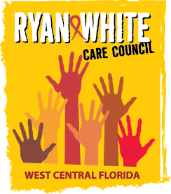
WEST CENTRAL FLORIDA RYAN WHITE CARE COUNCIL
RESOURCE PRIORITIZATION AND ALLOCATION RECOMMENDATIONS
SUNCOAST HOSPICE, CLEARWATER
THURSDAY, JANUARY 12, 2017
11:00 A.M. - 12:30 P.M.

AGENDA

- Call to Order Chair

- Roll Call Staff

- Changes to Agenda Members

- Adoption of Minutes Chair
November 10, 2016 (Attachment)

- Care Council Report Co-Chair

- Quarterly Expenditure Reports Members
1. Part A (Attachment)
2. Part B (Attachment)

VII. Part A Reallocation Request (Attachment) Members

VIII. Community Input/Announcements Chair/Members

IX. Adjournment Chair

Note: Items in bold are action items.

The Ryan White Care Council’s next meeting will be February 1, 2017 at the Children’s Board of Hillsborough County from 1:30pm-3:30pm.

The CARE COUNCIL website is at www.thecarecouncil.org. Meeting information, agendas and minutes will be posted on this website.

