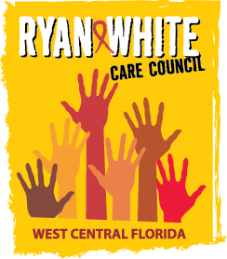

WEST CENTRAL FLORIDA RYAN WHITE CARE COUNCIL
RESOURCE PRIORITIZATION AND ALLOCATION RECOMMENDATIONS
SUNCOAST HOSPICE, CLEARWATER
THURSDAY, NOVEMBER 10, 2016
11:00 A.M. – 12:30 P.M.

MINUTES
CALL TO ORDER | The meeting was called to order by Nolan Finn, Chair at 11:02 a.m.
ATTENDANCE | Members Present: Marty Clemmons, Nolan Finn, David Konnerth, Marilyn Merida, Priya Rajkumar, Jim Roth, Elizabeth Rugg, Joy Winheim  Members Absent: Carla Baity, Ginny Boucher, Brandi Geoit, Charlie Hughes  Guests Present: Roberta Lambert, Vicky Oliver, Adrianne Emanuel  Recipient Staff Present: Aubrey Arnold  Lead Agency Staff Present: Demarcus Holden, Floyd Egner  Health Council Staff Present: Lisa Nugent, Samantha Nevins, Katie Scussel
CHANGES TO AGENDA | Nolan Finn requested to move the AAM Presentation to an Action Item. Demarcus Holden requested to have the Part B Reallocation Request added to the agenda for review and discussion.
ADOPTION OF MINUTES | The minutes for September 8, 2016 were approved (M: Roth; S: Rajkumar).
CARE COUNCIL REPORT | Marty Clemmons, Care Council Chair, announced that the Council did not meet in November so no report was given.  The next Care Council Meeting will be on December 7th and will take place at the Hillsborough County Children’s Board.
FINAL COMMITTEE WORKPLAN (attachment) | Goals/Objectives/Activities were reviewed by the committee members; there were no additions or deletions.
PART A RECIPIENT UPDATE | Aubrey Arnold announced the upcoming Case Manager Training taking place on November 18^{th.} The training will provide tools to assist clients in selecting the appropriate healthcare plan during open enrollment.  Aubrey reminded the committee that the Minority AIDS Initiative (MAI) Request for Applications (RFA) applications are due by 5:00pm Tuesday, December 6th, and that there be a Database Training on December 8th and 9th in anticipation of the launch of the new database, e2Hillsborough, on January 1, 2017.
LEAD AGENCY UPDATE | Demarcus Holden announced a Request for Applications (RFA) for Ryan White Part B funding and that he is in need of two more reviewers. He also announced that a new Contract Manager has been hired.  He presented a Part B Reallocation Request to the committee and provided rationale for moving the funds. Discussion ensued. A motion was made to approve the Reallocation Request (M: Rajkumar; S: Rugg). The motion was approved by a roll call vote.  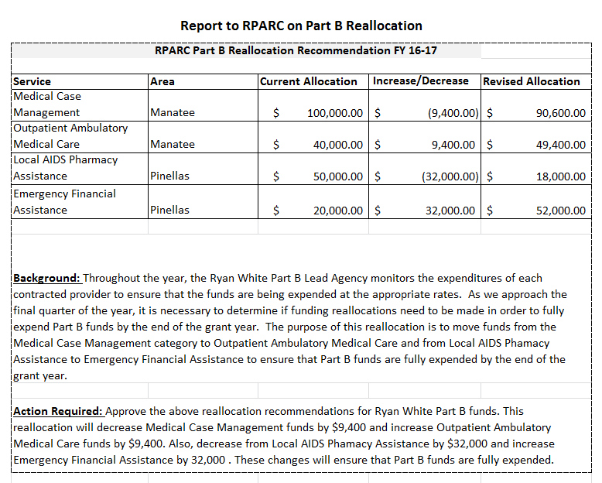
ASSESSMENT OF THE ADMINISTRATIVE MECHANISM FINDINGS (AAM) | David Cavalleri presented the results of the most recent Assessment of Administrative Mechanism (Part A, FY 2015-2016). Recommendations for improvements can be found on pages 32-34 of the Provider Summary Findings presentation provided in the meeting.  A motion was made to accept the report (M: Rajkumar; S: Konnerth). The motion was approved by acclamation.
COMMUNITY INPUT/ANNOUNCEMENTS | Demarcus Holden announced that a World AIDS Day event will take place at the South County ASAP Office on Thursday, December 1st at 3:00pm.
ADJOURNMENT | There being no further business to come before the committee, the meeting was adjourned at 12:34 p.m.

