**HIV/AIDS Epidemiology Report for the**

**Tampa- St. Petersburg Eligible Metropolitan Area**

**Adopted: May 3rd, 2017**

**2016-2017**

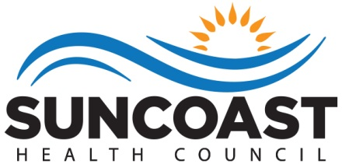

Helen King, Board Chair

Elizabeth Rugg, Executive Director

Lisa Nugent, Planning Director

**Who We Are**

The health councils were created in 1983 by Florida Statute to identify, address and resolve health care issues of local concern. Each health council is a private, non-profit organization governed by a Board of Directors. The Board members are appointed by County Commissioners to represent the concerns of health care consumers, providers and purchasers.

The Suncoast Health Council, Inc. (SHC) serves Pasco and Pinellas counties. The Council has extensive experience working with for-profit and non-profit agencies, public health organizations, consumers and professionals. Collaboration and cooperation are critical to the success of our mission.

We have three strategic goals: (1) support the accessibility of health care and social support systems through *comprehensive health planning*; (2) obtain and provide *education* about essential community health challenges and solutions; and (3) participate as collaborative partners to develop and sustain efficient and cost effective *service delivery* systems.

**Suncoast Health Council, Inc.**

**Board of Directors**

Terri Briseno

Vonda Colquitt

Rob Marlowe (Acting Chair)

Natasha Martin

Lillian Okpaleke

Ginny Nelson

Patricia Quigley, MD

Louanne Saraga Walters

Nadine Spring

Jared Tur

**To Learn More About the Health Council**

Visit our website - www.SuncoastHealthCouncil.org

Or Contact Us:

Suncoast Health Council, Inc.

9600 Koger Blvd., Suite 221

St. Petersburg, FL 33702

727-217-7070

727-570-3033 (Fax)

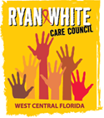

**WEST CENTRAL FLORIDA RYAN WHITE CARE COUNCIL**

Mission Statement

We are a planning body that assesses needs, plans, allocates resources, and evaluates HIV/AIDS services to improve the lives of those infected and affected.

Members

Antuan Butler

Martin Clemmons, Jr.

Lisa Conder

Paula Delgado

Eda Dugas

Tonicia Freeman-Foster

Brandi Geoit

Kirsty Gutierrez

Charlie Hughes

Joyce Johnson

Riley Johnson

Dave Konnerth

Kamaria Laffrey

Maribel Martinez

Bernard Messier

Kimberly Molnar

Sherri Montiy

Alice Prendergast

Guttenberg Pierre, Jr.

Pamela Sabella

Michael Sodano

Debbie Stephey

Barbara Szelag

Dean Underwood

Bernard Washington

Produced on behalf of The Ryan White Care Council under contract with the Health Care Services Department within the Human Services of Hillsborough County; Ryan White Program. Funded by HRSA and the State of Florida, Department of Health.

**INTRODUCTION**

The Tampa**-**St. Petersburg Eligible Metropolitan Area (EMA), located on the west central coast of Florida, is comprised of Hernando, Hillsborough, Pasco, and Pinellas Counties. The EMA utilizes Ryan White HIV/AIDS Program (RWHAP) Part A grant funds in support of a comprehensive continuum of high-quality care and treatment for people living with HIV/AIDS (PLWHA) in the service area.

The purpose of this project is to achieve the goals as defined in the National HIV/AIDS Strategy (NHAS) and to facilitate, support, and execute the mission of the West Central Florida Ryan White Care Council (herein referred to as Planning Council): *The Care Council is a planning body (of dedicated volunteers) that assesses needs, plans, allocates resources, and evaluates HIV/AIDS services to improve the lives of those infected and affected.*

**Epidemiology OVERVIEW**

1) The Tampa-St. Petersburg Eligible Metropolitan Area (EMA)’s total population is approximately 2.9 million, of which 66% are White (non-Hispanic), 17% are Hispanic and 12% are Black (non-Hispanic). Women represent 51.5% of the total population. The image below depicts the geographic layout of the EMA.

Tampa-St. Petersburg EMA

Geographic Layout



The following data provides a description of the sociodemographic, geographic, behavioral, and clinical characteristics of persons newly diagnosed with HIV and persons at higher risk for infection. This information is used by the local area to set priorities, identify interventions and services, and to allocate resources to HIV prevention and care. This epidemiologic overview focuses on the most recent year for which data is available with five year trend data as appropriate.

The socioeconomic status of individuals living in the EMA varies throughout the four county area. According to the American Community Survey, in 2014 the median household income of residents living in Hillsborough ($50,122) and Hernando Counties ($40,457) has a wide range while the median household income of Pinellas ($45,574) and Pasco Counties ($44,518) show less variability. The percentage of individuals living below the federal poverty level ranges from 14.3% in Pasco County to 17.2% in Hillsborough County. The percentage of adults in each county who have any type of health insurance ranges from 82.3% in Hillsborough to 84.2% in Pasco. The percentage of EMA residents over the age of 25 with a high school diploma or higher ranges from 89.4% of residents in Pinellas County to 86.6% in Hernando County. The percentage of persons over the age of 25 who possess a bachelor’s degree or higher ranges from 15.7% in Hernando County to 29.8% in Hillsborough County.

According to the Florida Department of Health’s Epidemiological Profile, the incidence of HIV in the EMA rose 19% since 2011. New cases of AIDS increased 12% since 2011. The most common mode of transmission for HIV and AIDS in the EMA was men who have sex with men (MSM) followed by heterosexual transmission, and injection drug use (IDU).

**Figure 1: Tampa/St. Petersburg EMA Epidemiological Profile**

|  |  |  |  |  |  |  |  |  |  |  |
| --- | --- | --- | --- | --- | --- | --- | --- | --- | --- | --- |
|  | **CY 2011** | | **CY 2012** | | **CY 2013** | | **CY 2014** | | **CY 2015** | |
| **Incidence** | **Prevalence** | **Incidence** | **Prevalence** | **Incidence** | **Prevalence** | **Incidence** | **Prevalence** | **Incidence** | **Prevalence** |
| **HIV** | 522 | 4,802 | 502 | 4,836 | 499 | 5,010 | 557 | 5,273 | 594 | 5,567 |
| **AIDS** | 347 | 6,252 | 365 | 5,546 | 351 | 6,687 | 336 | 6,881 | 309 | 6,973 |
| **TOTAL** | 869 | 11,054 | 867 | 10,382 | 850 | 11,697 | 893 | 12,154 | 903 | 12,540 |

Source: Florida Department of Health, Tampa-St. Petersburg EMA Epidemiological Profiles CY 2011,

2012, 2013, 2014 and 2015.

2) **Attachment 1** describes the demographic data of PLWHA in the EMA including race, age, sex, and transmission category.

The most common mode of transmission for newly diagnosed individuals living with HIV/AIDS over the five year time-span is MSM with 838 new cases of AIDS and 1,660 new cases of HIV. Heterosexual contact accounted for 594 new AIDS cases and 730 new HIV cases. IDU transmission was the third highest mode of transmission with 173 HIV cases and 181 AIDS cases.

The incidence of HIV among males in the EMA increased from 409 cases in 2011 to 487 cases in 2015; a 25.5% increase. During the same time frame, new HIV cases among females decreased by 4% from 113 to 107. The incidence of male AIDS cases decreased 13%, from 249 to 232 cases. The incidence of female AIDS cases decreased 9% from 2011-2015; 98 to 77 cases.

Source: Florida Department of Health, Tampa-St. Petersburg EMA Epidemiological Profiles CY 2011, 2012, 2013, 2014 and 2015.

As shown in Figure 2, over the past five years there has been an increase in the incidence of HIV in the EMA for Blacks and Hispanics. The HIV incidence rose 10% and 81% respectively. From 2011 to 2015, the incidence of AIDS among Hispanics in the EMA rose 17% and the incidence among Blacks decreased 14% (Figure 3). The incidence of AIDS among Whites in the EMA decreased 19%, while the incidence of HIV among Whites decreased by 9% from 2011-2015.

The 2015 calendar year saw minor demographic changes in HIV and AIDS prevalence. Whites in the EMA represented two thirds of the population and had the highest percentage of HIV cases at 45%. Blacks accounted for 37% and Hispanics represented 16% of HIV cases. Whites represented the largest prevalence of AIDS cases in the EMA with 47%, followed by Blacks with 35% and Hispanics with 16%. Blacks were disproportionately impacted by HIV/AIDS. Blacks made up only 12% of the population within the EMA in 2015 and represented 37% of HIV cases and 35% of the AIDS cases.

In 2015, men represented 74.2% and 74.8% of HIV and AIDS prevalence respectively. In the EMA, men comprise approximately 48.6% of the population but represent a majority of HIV and AIDS cases. Women represented 25.8% and 25.2% of HIV and AIDS cases respectively.

Overall, there has been an increase in HIV/AIDS prevalence in every race and ethnicity category in the last five years. Hispanics in the EMA saw the greatest increase in HIV/AIDS prevalence from 1,571 cases in 2011 to 2,031 cases in 2015.

Sociodemographic indicators of PLWHA in the EMA were assessed through data reporting and client needs assessment surveys. According to the 2013 Client Survey, the PLWHA population in the EMA has an unemployment rate of 65%, and 41.5% of PLWHA are without insurance. Of the clients receiving Part A funded services who reported their incomes, 96.9% reported incomes less than 300% of the Federal Poverty Level (FPL), 80% report incomes less than 200% FPL and 59.9% reported incomes of less than 100% FPL.

Additional socioeconomic data for PLWHA in the EMA including percentage of federal poverty level, income, and health insurance status is included in the Impact of the Changing Health Care Landscape section of this document.

3) Burden of HIV in the service area:

Figure 4 depicts the presumed living HIV/AIDS cases in each of the EMA’s four counties as of 10/30/15. The EMA’s urban counties (Hillsborough and Pinellas) experienced a greater number of HIV/AIDS cases compared to the rural counties (Hernando and Pasco).

**Figure 4:**

**Tampa-St. Petersburg EMA** **HIV/AIDS Cases per County**

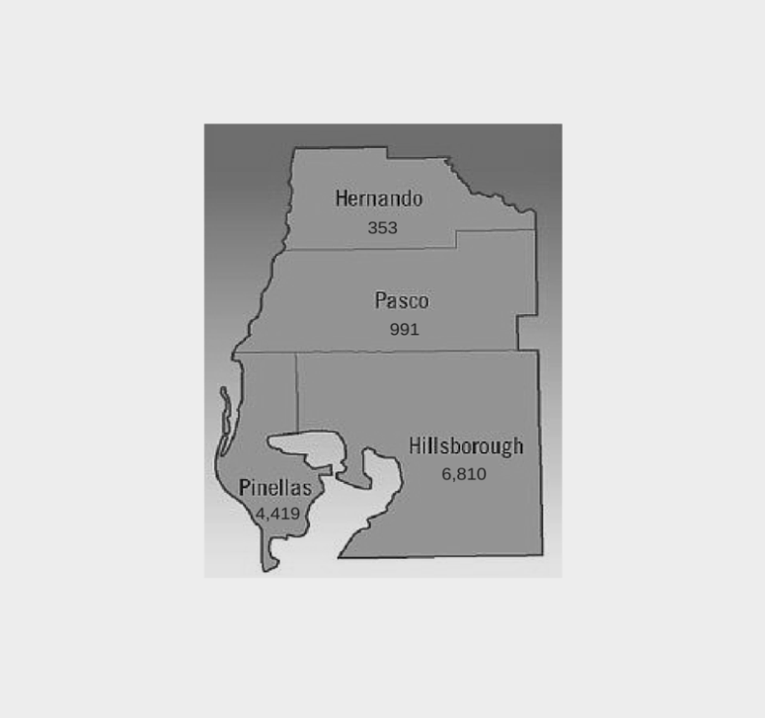

Source: Florida Department of Health, Monthly Surveillance Report, October 2015.

Figure 5 highlights possible HIV exposure categories as acknowledged by individuals during testing. Over a five year period (2011-2015), the highest tested exposure category was heterosexual contact. The second highest exposure category was STD diagnosis, followed by Men who have Sex with Men (MSM). Although the heterosexual exposure category had the highest number of tests, MSM had the highest number of positive tests from 2011-2015.

**Figure 5: Testing in the EMA by Possible Exposure Category**

|  |  |  |  |  |  |  |  |  |  |  |
| --- | --- | --- | --- | --- | --- | --- | --- | --- | --- | --- |
| **Exposure Category** | **2011** | | **2012** | | **2013** | | **2014** | | **2015** | |
| Number of Tests | Positive Tests | Number of Tests | Positive Tests | Number of Tests | Positive Tests | Number of Tests | Positive Tests | Number of Tests | Positive Tests |
| **MSM/IDU** | 148 | 22 | 178 | 18 | 240 | 19 | 250 | 18 | 295 | 18 |
| **MSM** | 3,600 | 234 | 3,752 | 226 | 4,456 | 220 | 4,514 | 215 | 5,427 | 269 |
| **IDU** | 2,861 | 25 | 2,699 | 20 | 3,012 | 24 | 3,076 | 20 | 3,844 | 16 |
| **Sexual Partner at Risk** | 2,353 | 98 | 2,724 | 48 | 2,404 | 67 | 1,822 | 78 | 1,935 | 62 |
| **Child of Women with HIV/AIDS** | 122 | 1 | 89 | 4 | 54 | 0 | 10 | 0 | 5 | 0 |
| **STD Diagnosis** | 8,564 | 38 | 7,806 | 37 | 7,524 | 31 | 7,873 | 37 | 8,005 | 39 |
| **Sex for Drugs or Money** | 408 | 4 | 337 | 2 | 316 | 4 | 262 | 4 | 281 | 2 |
| **Hemophilia/ Blood Recipient** | 0 | 0 | 0 | 0 | 0 | 0 | 0 | 0 | 0 | 0 |
| **Victim of Sexual Assault** | 1,388 | 7 | 1,187 | 10 | 567 | 4 | 150 | 1 | 111 | 1 |
| **Health Care Exposure** | 0 | 0 | 0 | 0 | 0 | 0 | 0 | 0 | 0 | 0 |
| **Heterosexual** | 23,272 | 75 | 18,089 | 76 | 18,712 | 67 | 16,617 | 79 | 15,277 | 46 |
| **No Acknowledged Risk** | 421 | 1 | 384 | 5 | 413 | 4 | 1,491 | 8 | 288 | 0 |
| **Unknown** | 1,429 | 12 | 1,539 | 20 | 1,957 | 15 | 447 | 1 | 1,089 | 10 |
| **Total** | **44,566** | **517** | **38,784** | **466** | **39,655** | **455** | **36,512** | **461** | **36,557** | **463** |

Source: Florida Department of Health, Tampa-St. Petersburg EMA Epidemiological Profiles CY 2011, 2012, 2013, 2014, and 2015.

Figure 6 shows the number of HIV/AIDS case deaths by race/ethnicity from 2011-2015. All race/ethnicity categories experienced a higher number of deaths in 2015 compared to the previous four years.

Source: Florida Department of Health, Tampa-St. Petersburg EMA Epidemiological Profiles CY 2011, 2012, 2013, 2014, and 2015.

4) Indicators of risk for HIV infections:

Indicators of risk for acquiring/identifying HIV infection include: HIV testing, unwanted sexual experiences, healthcare-seeking behaviors, and the presence of sexually transmitted infections such as chlamydia, syphilis and gonorrhea. Behavioral data available for the EMA is included when known, in addition to HIV surveillance and testing data, client level data for Ryan White HIV/AIDS Program (RWHAP) Part A clients and AIDS Drug Assistance Program (ADAP) clients, relevant other surveillance program data, and vital statistics. These data points help to portray the potential risk for new HIV infections in the EMA.

a) Behavioral surveillance data:

Figure 7 shows that all parts of the Tampa-St. Petersburg EMA had higher rates than the State of Florida for adults who had an unwanted sexual experience in the past 12 months in 2007. Pasco County had the highest rate at 9.6%, almost a full 3% higher than the state of Florida.

Source: Florida Behavioral Risk Factor Surveillance System county-level telephone survey conducted by the Centers for Disease Control and Prevention (CDC) and Florida Department of Health Bureau of Epidemiology, 2007.

Figure 8 depicts the healthcare-seeking behavior for individuals in the EMA. All counties in the EMA have rates that are just above the State of Florida for adults with any type of health care insurance coverage. At least 80% of adults in the EMA had some type of health insurance and 70.9% - 73.1% of adults had a medical checkup in the last year. Approximately 15.5%-19.6% of adults in the EMA were not able to see a doctor in the last year due to cost.

Source: Behavioral Risk Factor Surveillance System (BRFSS), 2013 County Level Reports.

b) HIV Surveillance Data: Figure 9 depicts HIV testing in the Tampa-St. Petersburg EMA from 2011-2015. It indicates a general decrease in testing among all races. 2011 had the highest number of testing events. There has been a decrease in testing events over the last four years.

Source: Florida Department of Health, Tampa-St. Petersburg EMA Epidemiological Profiles CY 2011, 2012, 2013, 2014, and 2015.

Figure 10 illustrates the percentage of adults under 65 years of age who had an HIV test in the past 12 months. Two of the counties in the EMA, Pasco and Hernando, had significantly lower testing rates compared to the state. Pasco County had a testing rate of 8.4% and Hernando County had a testing rate of 10.15% compared to the state’s rate of 15.6%.

Source: Florida Behavioral Risk Factor Surveillance System County-level telephone survey conducted Centers for Disease Control and Prevention (CDC) and Florida Department of Health Bureau of Epidemiology, 2014.

c) RWHAP data:

Figures 11 and 12 depict Ryan White HIV/AIDS Program Services Report (RSR) data for calendar year 2015. The data represent Ryan White clients in the Tampa –St. Petersburg EMA. The data is not part-specific; that is, all tables include clients served across Ryan White HIV/AIDS Program (RWHAP) funding steams.

Source: Ryan White HIV/AIDS Program Services Report (RSR), Tampa-St. Petersburg EMA CY 2015.

The demographic characteristics of the EMA’s RWHAP clients are similar to the overall prevalence of HIV/AIDS in the EMA by gender and race. Whites in the EMA account for 45% of HIV and 47% of AIDS cases and account for 39.8% of clients who receive RWHAP services. Ryan White utilization by gender as well as among Blacks and Hispanics are within a 3.5% variance of their respective prevalence in the EMA.

Source: Ryan White HIV/AIDS Program Services Report (RSR), Tampa-St. Petersburg EMA CY 2015.

The percentage of Ryan White clients with a suppressed viral load (less than 200 ml/copies) in the EMA was 78% for calendar year 2015. The average viral load for clients in 2015 was 14,853 ml/copies. The average CD4 count was 588.74 cells/mm3. Approximately 57% of all RWHAP clients had a CD4 count of 500 cells/mm3 in 2015. This data was captured from Part A and Part B funded Outpatient Ambulatory Medical Care (OAMC) providers.

The Florida AIDS Drug Assistance Program (ADAP) provides AIDS-specific medications at no cost to residents who qualify. Demographic disparities exist among racial and ethnic minorities with regards to accessing ADAP services in the EMA. Minority populations represent a greater proportion of HIV/AIDS cases within the EMA, but are accessing ADAP services in smaller numbers. Figure 13 shows the breakdown of ADAP clients by race.

Source: Florida Department of Health, Florida AIDS Drug Assistance Program, 2011-2014.

d) Other relevant demographic data: The EMA has seen a steady increase of chlamydia and syphilis from 2011-2015 (Figure 14). The number of new cases has gone down for tuberculosis in the five year period. The number of positive tests in 2015 for hepatitis C (n=4,454), chlamydia (n= 13,414), gonorrhea (n= 3,897) and syphilis (n= 394) represent the highest levels since 2011-2012. See Attachment 2 for more demographic data and co-morbidities.

Source: Florida Department of Health, Tampa-St. Petersburg EMA Epidemiological Profiles CY 2011, 2012, 2013, 2014, 2015.

Overall, the number of persons living with HIV has been on the rise in the Tampa-St. Petersburg EMA. Since 2011, the incidence rate of HIV has risen 19% in the EMA, as previously indicated. By studying the indicators of risk, the EMA can plan where to focus its attention to decrease the number of new HIV infections.

**THE EPIDEMIC BY AREA**

The State of Florida is broken down into numbered areas. The West Central Florida Ryan White Care Council covers three areas: Area 5, Area 6, and Area 14. The data is not available by county, only by area or EMA. In an effort to provide information regarding all the areas covered by the Care Council and not just the EMA, the following figures represent the three geographic areas that make up the Total Service Area (TSA).

**Figure 15: Area 5 includes Pasco and Pinellas counties**

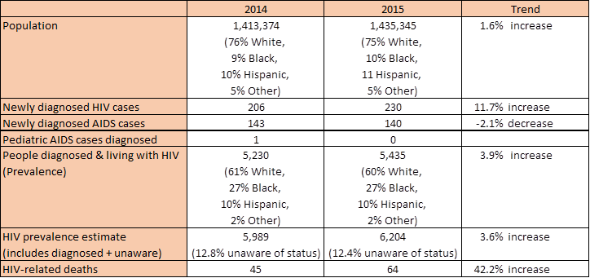

Source: Florida Department of Health, HIV/AIDS Section, 2016.

**Figure 16: Area 6 includes Hernando, Hillsborough, and Manatee counties**

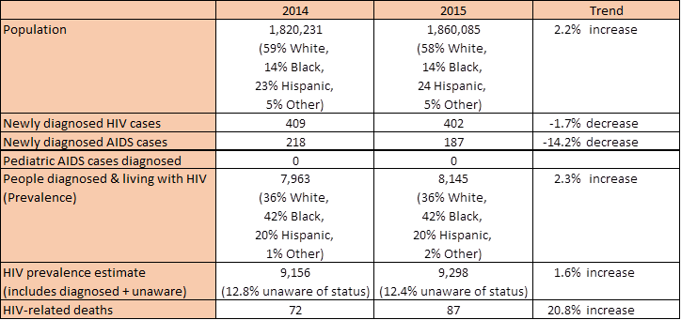

Source: Florida Department of Health, HIV/AIDS Section, 2016.

**Figure 17: Area 14 includes Hardee, Highlands, and Polk counties**

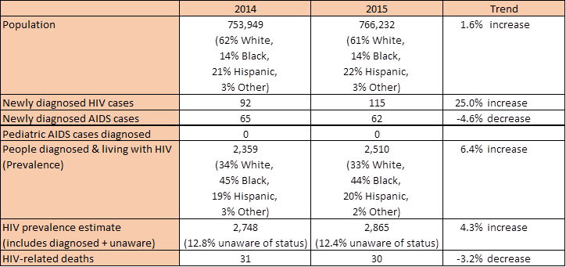

Source: Florida Department of Health, HIV/AIDS Section, 2016.

**ACKNOWLEDGMENTS**

The West Central Florida Ryan White Care Council wishes to recognize the contributions of the following:

**Planning and Evaluation Committee Members**

Jim Roth, Chair

Kirsty Gutierrez, Co-Chair

Ginny Boucher

Antuan Butler

Martin Clemmons, Jr.

Eda Dugas

Nicole Kish

Court Holloway

Sheryl Hoolsema

Marylin Merida

Vicky Oliver

Elizabeth Rugg

**Other Contributors**

Lorene Maddox, Florida Department of Health, Bureau of Communicable Disease, HIV/AIDS Section

|  |  |  |  |  |  |  |
| --- | --- | --- | --- | --- | --- | --- |
| **Demographic Group/**  **Exposure Category** | **2013- Prevalence as of 12/31/13** | | **2014-PREVALENCE AS OF 12/31/14** | | **2015-PREVALENCE AS OF**  **12/31/15** | |
| ***Race/Ethnicity*** | **HIV** | **AIDS** | **HIV** | **AIDS** | **HIV** | **AIDS** |
| White, not Hispanic | 2,275 | 3,223 | 2,388 | 3,262 | 2,473 | 3,269 |
| Black, not Hispanic | 1,845 | 2,307 | 1,935 | 2,408 | 2,037 | 2,463 |
| Hispanic | 776 | 1,013 | 838 | 1,058 | 941 | 1,090 |
| Other / Unknown | 114 | 144 | 112 | 153 | 116 | 151 |
| **Total** | 5,010 | 6,687 | 5,273 | 6,881 | 5,567 | 6,973 |
| ***Gender*** | **HIV** | **AIDS** | **HIV** | **AIDS** | **HIV** | **AIDS** |
| Male | 3,660 | 4,995 | 3,875 | 5,154 | 4,130 | 5,215 |
| Female | 1,350 | 1,692 | 1,398 | 1,727 | 1,437 | 1,758 |
| **Total** | 5,010 | 6,687 | 5,273 | 6,881 | 5,567 | 6,973 |
| ***Current Age as of Reporting Year*** | **HIV** | **AIDS** | **HIV** | **AIDS** | **HIV** | **AIDS** |
| <13 years | 17 | 4 | 13 | 4 | 13 | 4 |
| 13 - 24 years | 320 | 147 | 319 | 145 | 355 | 129 |
| 25 - 44 years | 2,143 | 1,829 | 2,253 | 1,793 | 2,357 | 1,731 |
| 45 - 59 years | 2,013 | 3,721 | 2,103 | 3,786 | 2,170 | 3,818 |
| 60+ years | 517 | 986 | 585 | 1,153 | 672 | 1,291 |
| **Total** | 5,010 | 6,687 | 5,273 | 6,881 | 5,567 | 6,973 |
| ***Exposure Category*** | **HIV** | **AIDS** | **HIV** | **AIDS** | **HIV** | **AIDS** |
| Men who have sex with men | 2,865 | 3,436 | 3,072 | 3,571 | 3,305 | 3,630 |
| Injection drug users | 387 | 778 | 388 | 762 | 406 | 759 |
| Men who have sex with men and inject drugs | 217 | 414 | 220 | 411 | 209 | 407 |
| Heterosexuals | 1,476 | 1,935 | 1,529 | 2,006 | 1,581 | 2,042 |
| Other/Unknown | 65 | 124 | 64 | 131 | 67 | 138 |
| **Total** | 5,010 | 6,687 | 5,273 | 6,881 | 5,568* | 6,976* |

**AIDS Prevalence and HIV (non AIDS) Prevalence Data by Demographic Group and Exposure Category**

Attachment 1

Source: Florida Department of Health EMA Epidemiological Profiles CY 2013; CY 2014; CY 2015

*Risk data are calculated values from a weighted database to redistribute the NIRs into known risks. Therefore, some risk data was off by one or two cases from the total due to rounding issues, according to the Florida Department of Health.

**PLWHA Co-Morbidities**

Attachment 2

**Tampa-St. Petersburg EMA**

|  |  |  |
| --- | --- | --- |
| **Co-morbidity** | **Co-Morbidity in PLWHA Population within EMA** | **Data Source** |
| **Infectious Syphilis** (diagnosed among HIV/AIDS patients) | 1,076.6* | PRISM (Patient Reporting, Investigation and Surveillance Manager)  Data through 2015 |
| **Gonorrhea** (diagnosed among HIV/AIDS patients) | 1,315.8* | PRISM (Patient Reporting, Investigation and Surveillance Manager)  Data through 2015 |
| **Chlamydia** (diagnosed among HIV/AIDS patients) | 1,188.2* | PRISM (Patient Reporting, Investigation and Surveillance Manager)  Data through 2015 |
| **Hepatitis C** (any HIV/AIDS case noted with a history of acute and/or chronic viral Hepatitis C and documented in eHARS and/or MERLIN) | 10,821.4* | Hepatitis Database matched with Florida eHARS and MERLIN  Data through 2015 |
| **Homelessness** (any living HIV/AIDS case who was homeless at diagnosis of HIV or AIDS and documented in eHARS) | 207.3* | Florida eHARS (enhanced HIV/AIDS Reporting System)  Data through 2015 |
| **Substance Abuse** (any living HIV/AIDS case noted with a history of substance abuse, e.g. alcohol, methamphetamine, cocaine, inhalents, etc.) | 19,274.3* | 2015 Florida eHARS (enhanced HIV/AIDS Reporting System)  Data through 2015 |
| **Chronic Mental Illness** (any HIV/AIDS case noted with a history of mental illness as documented in HARS) | 7,376.4* | 2015 Florida eHARS (enhanced HIV/AIDS Reporting System)  Data through 2015 |
| **Formerly Incarcerated** (HIV positive Florida Department of Corrections offenders released to the EMA in 2015) | 108 | Department of Corrections Offender-based Information System  Data for Calendar Year 2015 |

* Rate per 100,000 living HIV/AIDS cases

Attachment 3



