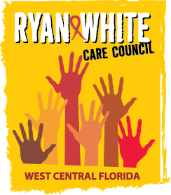
WEST CENTRAL FLORIDA RYAN WHITE CARE COUNCIL
COMMUNITY ADVISORY COMMITTEE
FRANCIS HOUSE - TAMPA
THURSDAY, JUNE 22, 2017
1:30 P.M. - 3:00 P.M.

AGENDA
- Call to Order Chair
- Roll Call Staff
- Changes to Agenda Members
- Adoption of Minutes (Attachment) Chair
May 25, 2017

- Care Council Report Co-Chair

- Client/Community Input Members

- Announcements Members/Guests

- Adjournment Chair

