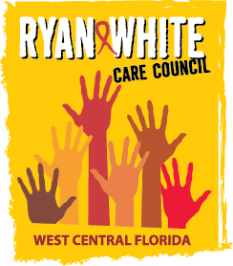
WEST CENTRAL FLORIDA RYAN WHITE CARE COUNCIL
RESOURCE PRIORITIZATION AND ALLOCATION RECOMMENDATIONS
SUNCOAST HOSPICE, CLEARWATER
THURSDAY, JUNE 8TH, 2017
11:00 A.M. - 12:30 P.M.

AGENDA

- Call to Order Chair

- Roll Call Staff

- Changes to Agenda Members

- Adoption of Minutes Chair
April 13th, 2017 (Attachment)
May 11th, 2017 (Attachment)

- Care Council Report Co-Chair

VI. 2018-19 Part A Allocations Discussion Members

VII. Community Input/Announcements Members

VIII. Adjournment Chair

Note: Items in bold are action items.

The Ryan White Care Council’s next meeting will be July 5th, 2017 at the Children’s Board of Hillsborough County from 1:30pm-3:30pm.

The CARE COUNCIL website is at www.thecarecouncil.org. Meeting information, agendas and minutes will be posted on this website.

