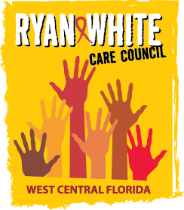
WEST CENTRAL FLORIDA RYAN WHITE CARE COUNCIL
RESOURCE PRIORITIZATION AND ALLOCATION RECOMMENDATIONS
SUNCOAST HOSPICE, CLEARWATER
THURSDAY, AUGUST 17, 2017
11:00 A.M. - 12:30 P.M.

AGENDA

- Call to Order Chair

- Roll Call Staff

- Changes to Agenda Members

- Adoption of Minutes Chair
July 13th, 2017 (Attachment)

- Care Council Report Co-Chair

VI. Allocation of Part B funds to HIV/AIDS Treatment Linkage Egner/Members

VII. End of Quarter Expenditure Report Egner/Holden

VIII. 2018-19 Part A Allocations Recommendations Members

IX. Community Input/Announcements Members

X. Adjournment Chair

Note: Items in bold are action items.

The Ryan White Care Council’s next meeting will be September 6th, 2017 at the Children’s Board of Hillsborough County from 1:30pm-3:30pm.

The CARE COUNCIL website is at www.thecarecouncil.org. Meeting information, agendas and minutes will be posted on this website.

