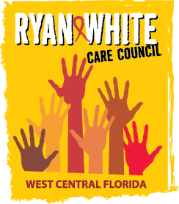
WEST CENTRAL FLORIDA RYAN WHITE CARE COUNCIL
COMMUNITY ADVISORY COMMITTEE
FRANCIS HOUSE
THURSDAY, SEPTEMBER 28, 2017
2:00 P.M. - 3:30 P.M.

AGENDA
- Call to Order Chair

- Roll Call Staff

- Changes to Agenda Members

- Adoption of Minutes Chair
August 24, 2017

- Care Council Report Co-Chair

- Meeting Location, Date & Time Members

- Election Chair / Co-Chair Members

- Committee Work Plan 2017-2018 Members

- Community Input Members

- Announcements Members/Guests
- Adjournment Chair

Note: Items in bold are action items.

The next meeting of the Ryan White Care Council will be October 4th, 2017 from 1:30pm to 3:30pm, at Suncoast Hospice in Clearwater.
The CARE COUNCIL website is operating at www.thecarecouncil.org. Agendas and minutes will be posted on this website.

