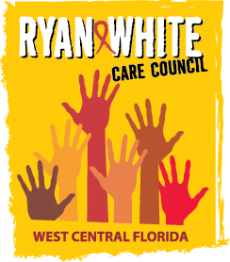
WEST CENTRAL FLORIDA RYAN WHITE CARE COUNCIL
RESOURCE PRIORITIZATION AND ALLOCATION RECOMMENDATIONS
SUNCOAST HOSPICE, CLEARWATER
THURSDAY, OCTOBER 12, 2017
11:00 A.M. - 12:30 P.M.

AGENDA

- Call to Order Chair

- Roll Call Staff

- Changes to Agenda Members

- Adoption of Minutes Chair
August 17th, 2017 (Attachment)

- Care Council Report Co-Chair

VI. Chair & Co-Chair Elections Members

VII. Meeting Time, Day, Location Members

VIII. Committee Work Plan (Attachment) Members

IX. Part A Reallocations Arnold/Members

X. Annual Work Plan Review Members

XI. Part A Expenditure Report (Attachment) Arnold

XII. Community Input/Announcements Members

XIII. Adjournment Chair

Note: Items in bold are action items.

The Ryan White Care Council’s next meeting will be November 1st, 2017 from 1:30pm to 3:30pm, at the Children’s Board of Hillsborough County.
The CARE COUNCIL website is at www.thecarecouncil.org. Meeting information, agendas and minutes will be posted on this website.

