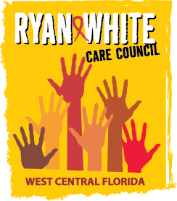
WEST CENTRAL FLORIDA RYAN WHITE CARE COUNCIL
PLANNING AND EVALUATION COMMITTEE
SUNCOAST HOSPICE, CLEARWATER
THURSDAY, DECEMBER 14, 2017
9:30 A.M. – 11:00 A.M.

MINUTES

CALL TO ORDER | The meeting was called to order by Jim Roth, Chair at 9:30 a.m.
ATTENDANCE | Members Present:, Jim Roth, Charlie Hughes, Marylin Merida, Lisa Condor, Elizabeth Rugg, Vicky Oliver, Kirsty Gutierrez  Members Absent:, Ginny Boucher, Sheryl Hoolsema, Nicole Kish  Guests Present: None  Recipient Staff Present: Dorinda Seth, Aubrey Arnold  Lead Agency Staff Present: Floyd Egner  Health Council Staff Present: Lisa Nugent, Naomi Ardjomand-Kermani
CHANGES TO AGENDA | None
ADOPTION OF MINUTES | The minutes for November 9, 2017 were approved (M: Hughes, S: Oliver).
CARE COUNCIL REPORT | The Care Council did not meet for the month of December.
REVIEW INTEGRATED PLAN | Members reviewed the integrated plan and member Charlie Hughes shared, with the group that presented responsible parties for data collection and outcomes. Member reviewed list and asked questions regarding responsibilities. Chair, Jim Roth, also presented and Integrated Plan Tracking tool which members reviewed. Finally, members discussed funding, the scope of work, and management to successfully implement and track the plan.
COMMUNITY INPUT/ANNOUNCEMENTS | Floyd Egner announced that Disease Intervention specialist, Sharon Caruthers, passed away.  Aubrey Arnold announced that e2Hillsborough has reached a milestone with the 837 being released in early December and that further improvements are expected in 2018. Everyone will go live on the system in January 2018. The state may discontinue the use of CareWare, altogether, in April 2019.
ADJOURNMENT | There being no further business to come before the Committee, the meeting was adjourned at 10:09 am.

