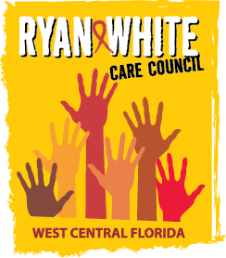
WEST CENTRAL FLORIDA RYAN WHITE CARE COUNCIL
RESOURCE PRIORITIZATION AND ALLOCATION RECOMMENDATIONS
SUNCOAST HOSPICE, CLEARWATER
THURSDAY, JANUARY 11, 2018
11:00 A.M. - 12:30 P.M.

AGENDA

- Call to Order Chair

- Roll Call Staff

- Changes to Agenda Members

- Adoption of Minutes Chair
December 7, 2017 (Attachment)

- Care Council Report Co-Chair

VII. Ryan White Membership Report Arnold

VIII. Recipient Update Arnold

IX. Community Input/Announcements Members

X. Adjournment Chair

Note: Items in bold are action items.

The Ryan White Care Council’s next meeting will be February 7, 2018 from 1:30pm to 3:30pm, at the Children’s Board of Hillsborough County.

The CARE COUNCIL website is at www.thecarecouncil.org. Meeting information, agendas and minutes will be posted on this website.

