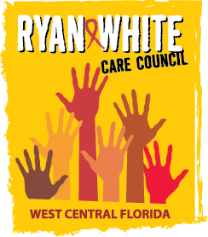
WEST CENTRAL FLORIDA RYAN WHITE CARE COUNCIL
HEALTH SERVICES ADVISORY COMMITTEE
CHILDREN’S BOARD OF HILLSBOROUGH COUNTY, TAMPA
THURSDAY, DECEMBER 21, 2017
1:30 P.M. – 3:00 P.M.

MINUTES

CALL TO ORDER | The meeting was called to order by Peggy Wallace, Chair at 1:37 PM.
ATTENDANCE | Members Present:, Jim Roth, Peggy Wallace, Bernice McCoy, Priya Rajkumar  Members Absent: Maribel Martinez  Guests Present: Terry Law, Kim Molnar, Tamara Robinson  Recipient Staff Present: Collette Lawson  Lead Agency Staff Present: none  Health Council Staff Present: Naomi Ardjomand-Kermani
CHANGES TO AGENDA | Removal of Client Satisfaction Survey
ADOPTION OF MINUTES | The minutes for September 21 were approved (M: Roth, S: McCoy).
CARE COUNCIL REPORT | The Care Council did not meet for the month of December.
MEETING TIME/DATE/LOCATION | A motion was made to keep the meeting time, day, and location the same (M: Roth; S: Rajkumar). The motion passed with acclamation.
REVIEW OF IMPACT OF ADAP & ACA | Affordable Care Act (ACA): Open enrollment is now close, but remains open until December 30th, for those who were affected by Hurricane Irma. Individuals must contact marketplace administrators to receive extension.
ANNOUNCEMENTS/  COMMUNITY CONCERNS | Providers discussed hours of operation for the holidays Kim Molnar announced that the AIDS walk and other World AIDS Day events were successfully held and received well by the public.  Jim Roth told members about the World AIDS Day event held at Hillsborough County Health Department.
ADJOURNMENT | There being no further business to come before the Committee, the meeting was adjourned at 1:45 p.m.

