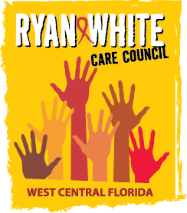
WEST CENTRAL FLORIDA RYAN WHITE CARE COUNCIL
COMMUNITY ADVISORY COMMITTEE
FRANCIS HOUSE
THURSDAY, APRIL 26, 2018
1:30 P.M. - 3:00 P.M.

AGENDA
- Call to Order Chair

- Roll Call Staff

- Changes to Agenda Members

- Adoption of Minutes Chair
March 22, 2018

- Care Council Report Co-Chair

- Client/Community Input Members

- Workplan Review

- Announcements Members/Guests
- Adjournment Chair

Note: Items in bold are action items.

The next meeting of the Ryan White Care Council will be May 2nd, 2018 from 1:30pm to 3:30pm, at The Children’s Board of Hillsborough County.
The CARE COUNCIL website is operating at www.thecarecouncil.org. Agendas and minutes will be posted on this website.

