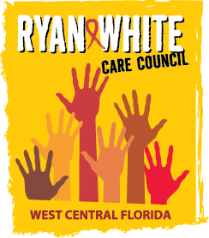
WEST CENTRAL FLORIDA RYAN WHITE CARE COUNCIL
COMMUNITY ADVISORY COMMITTEE
FRANCIS HOUSE
THURSDAY, SEPTEMBER 27, 2018
1:30 P.M. - 3:30 P.M.

AGENDA
- Call to Order Chair

- Roll Call Staff

- Changes to Agenda Members

- Adoption of Minutes Chair
August 23, 2018 (Attachment)

- Care Council Report Chair

- Meeting Location, Date & Time Members

- Election of Chair and Co-Chair Members

- Committee Work Plan 2018-2019 Members

- Client/Community Input Members

- Announcements Members/Guests
- Adjournment Chair

Note: Items in bold are action items.

The next meeting of the Ryan White Care Council will be October 3rd, 2018 from 1:30pm to 3:30pm, at The Children’s Board of Hillsborough County.
The CARE COUNCIL website is operating at www.thecarecouncil.org. Agendas and minutes will be posted on this website.

