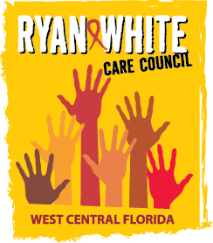
WEST CENTRAL FLORIDA RYAN WHITE CARE COUNCIL
RESOURCE PRIORITIZATION AND ALLOCATION RECOMMENDATIONS
SUNCOAST HOSPICE, CLEARWATER
THURSDAY, SEPTEMBER 13, 2018
11:00 A.M. - 12:30 P.M.

AGENDA

- Call to Order Chair

- Roll Call Staff

- Changes to Agenda Members

- Adoption of Minutes Chair
August 9, 2018

- Care Council Report Co-Chair

VI. Recipient Update Arnold

VII. Lead Agency Update Egner

VIII. Election of Chair and Co-Chair Members

IX. Meeting Time, Day, Location Members

X. Committee Work Plan (Attachment) Members

XI. Part B Expenditure Report Egner

XII. Community Input/Announcements Members

XIII. Adjournment Chair

Note: Items in bold are action items.

The Ryan White Care Council’s next meeting will be October 3, 2018 from 1:30pm to 3:30pm, at the Children’s Board of Hillsborough County.

The CARE COUNCIL website is at www.thecarecouncil.org. Meeting information, agendas and minutes will be posted on this website.

