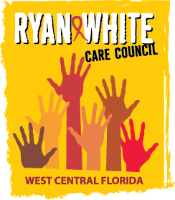
WEST CENTRAL FLORIDA RYAN WHITE CARE COUNCIL
COMMUNITY ADVISORY COMMITTEE
FRANCIS HOUSE
THURSDAY, JANUARY 24, 2019
1:30 P.M. - 3:30 P.M.

AGENDA
- Call to Order Chair

- Roll Call Staff

- Changes to Agenda Members

- Adoption of Minutes Chair
September 27, 2018 (Attachment)

October 25, 2018 (Attachment)

- Care Council Report Co-Chair

- Traveling Meetings – Dates, Times, and Locations Members

- Committee Work Plan 2018-2019 Members

- Client/Community Input Members

- Announcements Members/Guests

- Adjournment Chair

Note: Items in bold are action items.

The next meeting of the Ryan White Care Council will be February 6, 2019 from 1:30 pm to 3:30 pm, at The Lee Davis Community Center.
The CARE COUNCIL website is operating at www.thecarecouncil.org. Agendas and minutes will be posted on this website.

