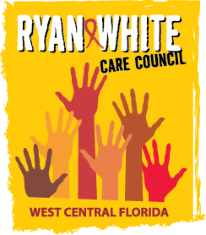
WEST CENTRAL FLORIDA RYAN WHITE CARE COUNCIL
RESOURCE PRIORITIZATION AND ALLOCATION RECOMMENDATIONS
SUNCOAST HOSPICE, CLEARWATER
THURSDAY, JANUARY 10, 2019
11:00 A.M. - 12:30 P.M.

AGENDA

- Call to Order Chair

- Roll Call Staff

- Changes to Agenda Members

- Adoption of Minutes Chair
November 8, 2018

- Care Council Report Co-Chair

VI. Recipient Update Arnold

VII. Lead Agency Update Egner

VIII. Community Input/Announcements Members

IX. Adjournment Chair

Note: Items in bold are action items.

The Ryan White Care Council’s next meeting will be February 6, 2019 from 1:30pm to 3:30pm, at the Children’s Board of Hillsborough County.

The CARE COUNCIL website is at www.thecarecouncil.org. Meeting information, agendas and minutes will be posted on this website.

