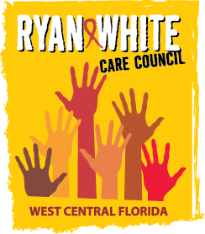
WEST CENTRAL FLORIDA RYAN WHITE CARE COUNCIL
COMMUNITY ADVISORY COMMITTEE
FRANCIS HOUSE
THURSDAY, FEBRUARY 28, 2019
1:30 P.M. - 3:00 P.M.

AGENDA
- Call to Order Chair

- Roll Call Staff

- Changes to Agenda Members

- Adoption of Minutes Chair
January 24, 2019 (Attachment)

- Care Council Report Co-Chair

- Polk & Pasco Meetings Members

- Review Ryan White Services and Testing Sites Members

- Client/Community Input Members

- Announcements Members/Guests

- Adjournment Chair

