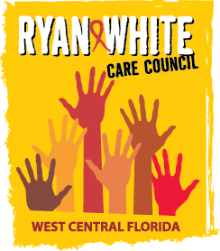
WEST CENTRAL FLORIDA RYAN WHITE CARE COUNCIL
RESOURCE PRIORITIZATION AND ALLOCATION RECOMMENDATIONS
SUNCOAST HOSPICE, CLEARWATER
THURSDAY, FEBRUARY 14, 2019
11:00 A.M. - 12:30 P.M.

AGENDA

- Call to Order Chair

- Roll Call Staff

- Changes to Agenda Members

- Adoption of Minutes Chair
January 10, 2019

- Care Council Report Co-Chair

VI. Recipient Update Arnold

VII. Part A Expenditure Report Arnold

VIII. Lead Agency Update Egner

IX Part B Reallocations Egner

X. Community Input/Announcements Members

XI. Adjournment Chair

Note: Items in bold are action items.

The next Care Council meeting will be held on March 6, 2019 from 1:30pm- 3:30pm at the Hillsborough County Center, Floor 26th Rooms 26A and 26B, located at 601 E. Kennedy Blvd, Tampa, FL 33602. Please park in the County Center parking garage - all parking will be validated (no cost to you).

The CARE COUNCIL website is at www.thecarecouncil.org. Meeting information, agendas and minutes will be posted on this website.

