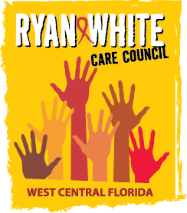
WEST CENTRAL FLORIDA RYAN WHITE CARE COUNCIL
COMMUNITY ADVISORY COMMITTEE
POSITIVELY U – WINTER HAVEN
340 1st STREET SOUTH
WINTER HAVEN, FL 33880
THURSDAY, MARCH 28, 2019
1:30 P.M. - 3:00 P.M.

AGENDA
- Call to Order Chair

- Roll Call Staff

- Changes to Agenda Members

- Adoption of Minutes Chair
January 24, 2019 (Attachment)

February 28, 2019 (Attachment)

- Care Council Report Co-Chair

- Client/Community Input Members

- Pasco County Meeting Members

- Announcements Members/Guests

- Adjournment Chair

Note: Items in bold are action items.

The next meeting of the Ryan White Care Council will be April 3, 2019 from 1:30 pm to 3:30 pm, at The Children’s Board of Hillsborough County.
The CARE COUNCIL website is operating at www.thecarecouncil.org. Agendas and minutes will be posted on this website.

