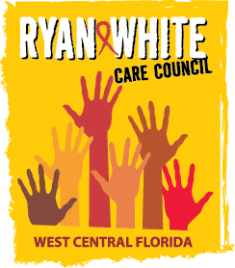
WEST CENTRAL FLORIDA RYAN WHITE CARE COUNCIL
COMMUNITY ADVISORY COMMITTEE
FRANCIS HOUSE - TAMPA
THURSDAY, MAY 23, 2019
1:30 P.M. - 3:00 P.M.

AGENDA
- Call to Order Chair

- Roll Call Staff

- Changes to Agenda Members

- Adoption of Minutes Chair
April 25, 2019 (Attachment)

- Care Council Report Chair

- Moment of Inspiration Members

- Client/Community Input Members

- Announcements Members/Guests

- Adjournment Chair

Note: Items in bold are action items.

The next meeting of the Ryan White Care Council will be June 5, 2019 from 1:30 pm to 3:30 pm, at The Children’s Board of Hillsborough County.
The CARE COUNCIL website is operating at www.thecarecouncil.org. Agendas and minutes will be posted on this website.

