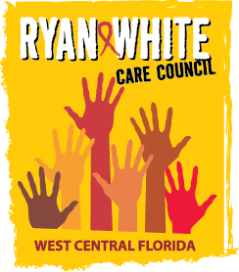
WEST CENTRAL FLORIDA RYAN WHITE CARE COUNCIL
COMMUNITY ADVISORY COMMITTEE
FLORIDA DEPARTMENT OF HEALTH IN PASCO
EDUCATION CENTER—SIDE B
THURSDAY, JULY 25, 2019
1:30 P.M. - 3:00 P.M.

AGENDA
- Call to Order Chair

- Roll Call Staff

- Changes to Agenda Members

- Adoption of Minutes Chair
June 27th 2019 (Attachment)

- Care Council Report and Care Council Overview for Guests Co-Chair/Staff

- Moment of Inspiration Members

- Client/Community Input Members

- Announcements Members/Guests

- Adjournment Chair

