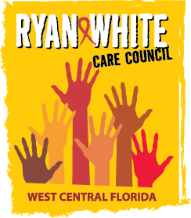
WEST CENTRAL FLORIDA RYAN WHITE CARE COUNCIL
COMMUNITY ADVISORY COMMITTEE
FRANCIS HOUSE – ANNEX BUILDING
THURSDAY, SEPTEMBER 26, 2019
1:30 P.M. - 3:00 P.M.

AGENDA
- Call to Order Chair

- Roll Call Staff

- Changes to Agenda Members

- Adoption of Minutes Chair
June 27th 2019 (Attachment)
July 25th 2019 (Attachment)

- Care Council Report Co-Chair

- Moment of Inspiration Members

- Meeting Location, Date, and Time Members/Staff

- Election of Committee Chair and Co-Chair Members

- Committee Work Plan 2019-2020 Members

- Client/Community Input Members

- Announcements Members/Guests

- Adjournment Chair

Note: Items in bold are action items.

The next meeting of the Ryan White Care Council will be October 2, 2019 from 1:30 pm to 3:30 pm, at The Children’s Board of Hillsborough County.
The CARE COUNCIL website is operating at www.thecarecouncil.org. Agendas and minutes will be posted on this website.

