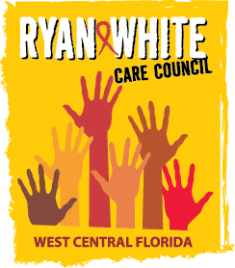
WEST CENTRAL FLORIDA RYAN WHITE CARE COUNCIL
RESOURCE PRIORITIZATION AND ALLOCATION RECOMMENDATIONS
SUNCOAST HOSPICE, CLEARWATER
THURSDAY, FEBRUARY 13, 2020
11:00 A.M. - 12:30 P.M.

AGENDA

- Call to Order Chair

- Roll Call Staff

- Changes to Agenda Members

IV. Adoption of Minutes Chair
November 14, 2019 (Attachment)

V. Care Council Report Co-Chair

VI. Recipient Update Arnold

VII. Part A Expenditure Report Arnold

VIII. Lead Agency Update Egner

IX. Part B Expenditure Report Egner

X. Community Input/Announcements Members

XI. Adjournment Chair

Note: Items in bold are action items.

The Ryan White Care Council’s next meeting will be March 4, 2020 from 1:30pm to 3:30pm, at the Children’s Board of Hillsborough County.

The CARE COUNCIL website is at www.thecarecouncil.org. Meeting information, agendas and minutes will be posted on this website.

