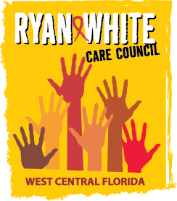

WEST CENTRAL FLORIDA RYAN WHITE CARE COUNCIL
RESOURCE PRIORITIZATION AND ALLOCATION RECOMMENDATIONS
GOTOWEBINAR
THURSDAY, MAY 14, 2020
11:00 A.M. – 12:30 P.M.

MINUTES
CALL TO ORDER | The meeting was called to order by the Chair, Dave Konnerth, at 11:04 a.m.
ATTENDANCE | Members Present: Nolan Finn, Dave Konnerth, Priya Rajkumar, Elizabeth Rugg, Marylin Merida, Joy Winheim  Members Absent: None.  Guests Present: Lillie Bruton, Adrianna Emanuel  Recipient Staff Present: Aubrey Arnold, Maria Teresa Jaureguizar  Lead Agency Staff Present:  Health Council Staff Present: Lisa Nugent, Naomi Ardjomand-Kermani, Katie Scussel
CHANGES TO AGENDA | None.
ADOPTION OF MINUTES | The minutes for March 12, 2020 were approved by acclamation (M: Finn; S: Winheim).
CARE COUNCIL REPORT | RPARC Co-Chair and Care Council Chair, Nolan Finn, reported that the 2020 National Ryan White Conference would no longer be held in person, but rather virtually to reduce risk of exposure to COVID-19.  The full Part A award was received in early April in the amount of $10,484,379, a little over a 1% increase from last year. Discussion as to how these additional funds will be spent will take place at the upcoming RPARC meeting. The Recipient launched a survey to assess the community’s greatest needs in order to best distribute the funds. The Ending the HIV Epidemic (EtHE) is in the final stages of preparing for launch and request for applications (RFA) have been finalized and will be released shortly. Recipient, Aubrey Arnold, reminded Council members that the two services to be funded through EtHE, in year one, will be an expansion of the HIV Education and Risk Reduction (HERR) and Early Intervention Services (EIS) programs in both Hillsborough and Pinellas Counties. Part A received about $800,000 in EtHE grant funds that will be released through this procurement opportunity.  An additional grant was received through the 2020 Coronavirus Aid, Relief and Economic Security (CARES) Act which came unexpectedly on April 15. A total of $558,000 in COVID funding was received for the Tampa/St. Petersburg Eligible Metropolitan Area (EMA). These funds will be used to support providers who have incurred unexpected costs associated with the pandemic.  Arnold reminded members that we are entering the 2nd year of the capacity building and technical assistance grant around infrastructure for e2Hillsborough database. We are nearing end of year one for $100,000 annual award to expand reporting components and quality management dashboards. A training around implementation of these dashboards will be forthcoming.  The upcoming bi-annual Florida Comprehensive Planning Network (FCPN) meeting will be held virtually as well. Going forward all meetings will be held virtually until we enter a recovery period with COVID. The Council will be using GoToWebinar for various meetings that Council holds. Arnold ended his report by announcing the new Hillsborough County administrator, Bonnie Wise, who will be taking the helm from Mike Merrell as he retires on July 1, 2020.  Lead Agency staff, Lightsey announced that Yashika Everhart will be the new grants manager, starting May 15, 2020. Everhart will be overseeing the Lead Agency and ADAP program. He informed members that Pinellas’ EtHE has received their planning dollars, but still awaits the implementation dollars.  Council members voted on and adopted, by acclamation, the revised mission and vision statements. The Planning and Evaluation Committee presented the 2019-2020 Epidemiology report, for the Tampa/St. Petersburg Eligible Metropolitan Area (EMA), along with the EMA’s 2019 Care Continuum. Council members voted on and adopted both documents by acclamation.  Finally, Finn shared that the Quality Management consultant, David Cavalleri, announced that 8 out of 9 providers have responded to the Assessment of the Administrative Mechanism (AAM) survey. Only 12 Care Council and RPARC members have completed the survey at this time. Cavalleri then noted that he will be sending out the continuous quality management (CQM) survey to providers within the week.
RECIPIENT UPDATE | Recipient, Aubrey Arnold, informed committee members that Part A has received COVID funding and is in the process of creating a budget narrative. Arnold plans to bring the summary of items to be funded to the committee when finalized.
PART A EXPENDITURE REPORT | Arnold presented the FY 2019-2020 final Part A expenditure report and noted that over 99% of funds were expended. Residual funds, in the amount of $84,774.15, will be requested as carryover for FY 2019-2020 to fund direct services. He wrapped up the review by thanking providers for providing quality services despite added issues due to COVID-19.
ADDITIONAL PART A FUNDING ALLOCATION RECOMMENDATIONS | Arnold moved on to the next agenda item of allocation recommendations for the additional funding Part A has received. Allocations presented were broken down by general Part A funds and will result in an increase in Minority AIDS Initiative (MAI) funding. Additional funds provided by all 4 HRSA grants, funding Part A for FY 2020-2021, will represent some increases in administrative budgets as well.  Part A conducted a survey to determine how best to engage services, by greatest need, and these recommendations represent those needs, prioritized by category. Priority being Outpatient Ambulatory Health Services (OAHS).  Committee Co-Chair, Nolan Finn, pointed out that agencies were surveyed in early April, despite receiving the full award the end of March 2020. Finn went on to note that processes are ever-evolving due to the circumstances presented by COVID-19 and inquired if Part A will have sufficient funds for health insurance and other basic needs for clients who fall in the margins. Arnold responded that finances dedicated to housing are not available to the Recipient, but funds through Emergency Financial Assistance (EFA) will cover anti-retroviral drugs. However, the additional COVID funding will be routed to health insurance to alleviate client needs do to job insecurity and loss. Member, Priya Rajkumar, added that increased allocations to case management would help address clients’ basic needs as case managers are typically the providers navigating these services for clients.  Arnold added that Part A is working with the City of Tampa as they received additional Housing Opportunities for People with AIDS (HOPWA) funds. HOPWA has procurement opportunities at this time and Part A wants to ensure that services are not being duplicated.  Members, Marylin Merida and Priya Rajkumar, raised the point of how clients’ additional needs will result in the need for additional health education for all case management clients as they don’t have access to resources for prevention and other needs.  Review of recommendations continued with committee Chair, Dave Konnerth, raising concern that the procurement process may be an unnecessary burden on OAHS providers for such a small amount of funding ($15,000). Arnold agreed and ensured members that this issue is being considered as current applications are exhaustive and time-consuming.  Background  The RPARC is responsible for recommending to the Care Council the allocation of Part A funds. In the recent ’20-’21 HRSA announcement of funding, an additional $233,893 increase in funding for the current fiscal year was received. After surveying Part A providers there is need to increase support for MAI, Outpatient Ambulatory Health Services and Medical Cast Management. The Recipient’s office has presented the following for additional Part A fund allocation recommendations:  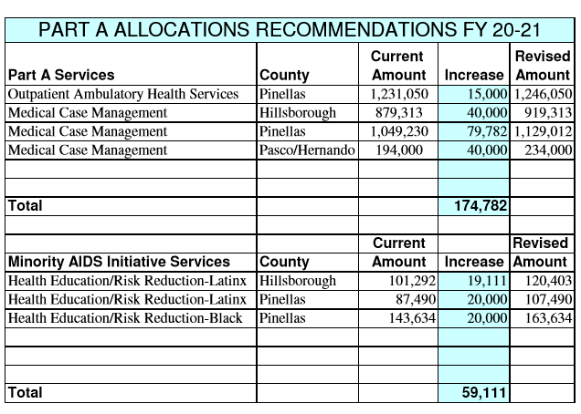  The allocation recommendations approved by acclamation (M: Rajkumer; S: Merida).
LEAD AGENCY UPDATE | Lead Agency staff, Darius Lightsey, had no report for Part B, but promised to bring expenditure reports to the June 2020 RPARC meeting for review. He noted that mostly all funds have been expended, but administrative funds were not spent-out due to being short-staffed.
COMMUNITY INPUT/ ANNOUNCEMENTS | Member, Joy Winheim, announced that EPIC will be hosting a drive-in movie on May 23 in the EPIC South County Service Center parking lot. They will be showing Mamma Mia for a $20 donation. Snacks and drinks will be served completely by Personal Protective Equipment (PPE) and social distancing.  Finally, Arnold announced the release of the Ending the HIV Epidemic (EtHE) grant opportunity and a pre-submittal conference will be held virtually on May 19, 2020. This conference will be publicly announced and will include Early Intervention Services (EIS) and Health Education/Risk Reduction (HERR).
ADJOURNMENT | There being no further business to come before the committee, the meeting was adjourned at 11:43 a.m.

