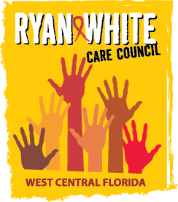
WEST CENTRAL FLORIDA RYAN WHITE CARE COUNCIL
WOMEN, INFANTS, CHILDREN, YOUTH AND FAMILIES COMMITTEE
GOTOWEBINAR
THURSDAY, JULY 23, 2020
10:00 AM – 11:30 AM

AGENDA

- Call to Order Chair

- Roll Call Staff

- Changes to Agenda Members

- Adoption of Minutes Chair
June 25, 2020 (Attachment)

- Care Council Report Co-Chair

- Moment of Inspiration Members

- Virtual Event Members

- Women/Youth Concerns/Updates Members

- Community and Client Concerns/Announcements Members/Guests

- Adjournment Chair

Note: Items in bold are action items.
The next meeting of the Ryan White Care Council will be on August 5, 2020 from 1:30 pm to 3:30 pm, via GoTo Webinar.
The CARE COUNCIL website is operating at www.thecarecouncil.org. Agendas and minutes will be posted on this website.

