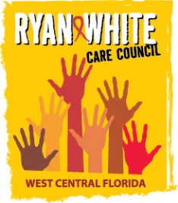
WEST CENTRAL FLORIDA RYAN WHITE CARE COUNCIL
VIRTUAL GOTOMEETING
WEDNESDAY, AUGUST 5, 2020
1:30 P.M. – 3:30 P.M.

AGENDA
I. Call to Order Finn
II. Roll Call and Introductions Finn
III. Changes to Agenda Finn
IV. Adoption of Minutes Finn
July 1, 2020 (Attachment)
V. Chairperson’s/Vice Chairperson’s Report Finn
1. Florida Comprehensive Planning Network Area Rep Election
VII. Moment of Silence Finn
VIII. Recipient’s Report Arnold
IX. Lead Agency Report Everhart/Lightsey
X. Care Council Planning Staff Report Ardjomand-Kermani/Scussel
  - Care Council Vice Chair Eligibility (Attachment)
  - Vice Chair Nominations
XI. Committee Reports
- Community Advisory Committee (CAC) Laffrey
- Health Services Advisory (HSAC) Rugg
- Membership Freeman-Foster
  - Membership Nomination (Attachment)
- Planning and Evaluation (P&E) Gutierrez
- Resource Prioritization & Allocation Recommendations (RPARC) Konnerth
- Standards, Issues and Operations (SIOC) Finn
- Women, Infants, Children, Youth & Families (WICY&F) Delgado
XII. Public Policy Report/Community Input Members/Guests
XIII. Prevention Activities/Quality Management Members/Guests
XIV. Announcements Members/Guests
XV. Adjournment Finn

Note: Items in bold require action. Care Council meetings are audio recorded.

The next Care Council meeting will be held on September 2, 2020 from 1:30pm- 3:30pm, by way of GoToWebinar.

The CARE COUNCIL website is operating at www.thecarecouncil.org. Agendas and minutes will be posted on this website.

