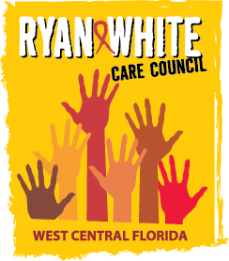
WEST CENTRAL FLORIDA RYAN WHITE CARE COUNCIL
COMMUNITY ADVISORY COMMITTEE
GOTOWEBINAR
THURSDAY, SEPTEMBER 24, 2020
1:30 P.M. - 3:00 P.M.

AGENDA
- Call to Order Chair

- Roll Call Staff

- Changes to Agenda Members

- Adoption of Minutes Chair
June 25, 2020 (Attachment)
August 27, 2020 (Attachment)

- Care Council Report Co-Chair

- Moment of Inspiration Members
- Meeting Date, Time, and Location Members
- Election of Committee Chair and Co-Chair Members
- 2020-2021 Committee Work Plan Members

- Client/Community Input Members

- Announcements Members/Guests

- Adjournment Chair

Note: Items in bold are action items.

The next meeting of the Ryan White Care Council will be Wednesday, October 7, 2020 from 1:30 pm to 3:30 pm, via GoTo Webinar.
The CARE COUNCIL website is operating at www.thecarecouncil.org. Agendas and minutes will be posted on this website.

