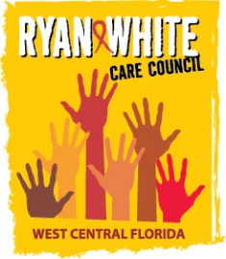
WEST CENTRAL FLORIDA RYAN WHITE CARE COUNCIL
VIRTUAL GOTOWEBINAR
WEDNESDAY, OCTOBER 7, 2020
1:30 P.M. – 3:30 P.M.

AGENDA
I. Call to Order Finn
II. Roll Call and Introductions Ardjomand-Kermani/Scussel
III. Changes to Agenda Finn
IV. Moment of Silence Finn
V. Adoption of Minutes Finn
- September 2, 2020 (Attachment)
VI. Chairperson’s/Vice Chairperson’s Report Finn
VII. Recipient’s Report Arnold
VIII. Lead Agency Report Everhart/Lightsey
IX. Care Council Planning Staff Report Ardjomand-Kermani/Scussel
X. Committee Reports
- Community Advisory Committee (CAC) Scussel
- Health Services Advisory (HSAC) Rugg
- Membership Freeman-Foster
  - Membership Renewals (Attachment)
  - Vice-Chair Election
- Planning and Evaluation (P&E) Gutierrez
- Resource Prioritization & Allocation Recommendations (RPARC) Konnerth
  - Final FY 19-20 Part B Expenditure Report (Attachment)
- Women, Infants, Children, Youth & Families (WICY&F) Delgado
XI. Public Policy Report/Community Input Members/Guests
XII. Prevention Activities/Quality Management Members/Guests
XIII. Announcements Members/Guests
XIV. Adjournment Finn

Note: Items in bold require action. Care Council meetings are audio recorded.

The next Care Council meeting will be held on November 4, 2020 from 1:30pm- 3:30pm, Location to be announced

The CARE COUNCIL website is operating at www.thecarecouncil.org.
Agendas and minutes will be posted on this website.

