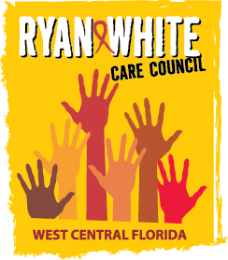
WEST CENTRAL FLORIDA RYAN WHITE CARE COUNCIL
HEALTH SERVICES ADVISORY COMMITTEE
GOTO WEBINAR
THURSDAY, OCTOBER 15, 2020
1:30 PM – 3:00 PM

AGENDA

- Call to Order Chair

- Roll Call and Introductions Staff/Members

- Changes to Agenda Members

- Adoption of Minutes Chair
August 20, 2020 (Attachment)

- Care Council Report Chair

VI. 2020-2021 Committee Updates Members
- Committee Location/Date/Time
- Committee Work Plan Update (Attachment)

VII. Election of Chair and Co-Chair (Attachment) Members

- Review Impact of ADAP & ACA Members

- Announcements/Community Concerns Members

- Adjournment Chair

Note: Items in bold require action by the membership.

The Ryan White Care Council’s next meeting will be November 4, 2020 from 1:30pm to 3:30pm, Location to be announced

The CARE COUNCIL website is at www.thecarecouncil.org. Meeting information, agendas and minutes will be posted on this website.

