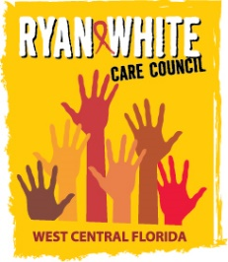
WEST CENTRAL FLORIDA RYAN WHITE CARE COUNCIL
PLANNING & EVALUATION COMMITTEE
SUNCOAST HOSPICE, CLEARWATER
MONDAY, OCTOBER 8, 2020
9:30 AM TO 11:00 AM

AGENDA

I. Call to Order Chair

II. Roll Call Staff

III. Adoption of Minutes Chair
September 10, 2020 (Attachment)

IV. Review of Service Priorities Members

V. Community Concerns & Announcements Members

VI. Adjournment Chair

Note: Items in bold are action items.

The Ryan White Care Council’s next meeting will be November 4, 2020 from 1:30pm to 3:30pm, Location to be announced

The CARE COUNCIL website is at www.thecarecouncil.org. Agendas and minutes will be posted on this website.

