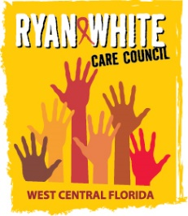
WEST CENTRAL FLORIDA RYAN WHITE CARE COUNCIL
PLANNING & EVALUATION COMMITTEE
GOTOWEBINAR
THURSDAY, DECEMBER 10, 2020
9:30 AM TO 11:00 AM

AGENDA

I. Call to Order Chair

II. Roll Call Staff

III. Adoption of Minutes Chair
October 8, 2020 (Attachment)

IV. Community Concerns & Announcements Members

V. Adjournment Chair

Note: Items in bold are action items.

The Ryan White Care Council’s next meeting will be January 6, 2020 from 1:30pm to 3:30pm, by way of GoToWebinar

The CARE COUNCIL website is at www.thecarecouncil.org.
Agendas and minutes will be posted on this website.

