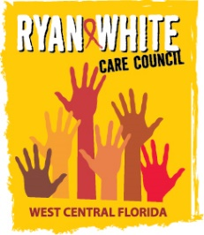
WEST CENTRAL FLORIDA RYAN WHITE CARE COUNCIL
PLANNING & EVALUATION COMMITTEE
GOTOWEBINAR
MONDAY, SEPTEMBER 10, 2020
9:30 AM TO 11:00 AM

AGENDA

I. Call to Order Chair

II. Roll Call Staff

III. Adoption of Minutes Chair
June 11, 2020 (Attachment)
August 13, 2020 (Attachment)

IV. 2020-2021 Committee Updates Members
- Committee Location/Date/Time
- Committee Work Plan Update (Attachment)

V. Election of Chair and Co-Chair (Attachment) Members

VI. Adjournment Chair

Note: Items in bold are action items.

The Ryan White Care Council’s next meeting will be October 7, 2020 from 1:30pm to 3:30pm, by way of GoToWebinar

The CARE COUNCIL website is at www.thecarecouncil.org. Agendas and minutes will be posted on this website.

