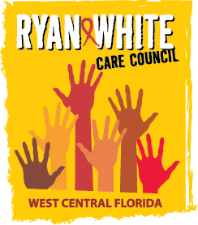
WEST CENTRAL FLORIDA RYAN WHITE CARE COUNCIL
RESOURCE PRIORITIZATION AND ALLOCATION RECOMMENDATIONS
SUNCOAST HOSPICE, CLEARWATER
THURSDAY, OCTOBER 8, 2020
11:00 A.M. - 12:30 P.M.

AGENDA

- Call to Order Chair

- Roll Call Staff

- Changes to Agenda Members

IV. Adoption of Minutes Chair
September 10, 2020 (Attachment)

V. Care Council Report Co-Chair

VI. Recipient Update Arnold

- Re-Allocation Recommendations

VII. Lead Agency Update Everhart

- Part B FY 19-20 Close-Out Expenditure Report (Attachment)

VIII. Assessment of the Administrative Mechanism (AAM) Cavalleri

IX. Updates from P&E Priority Setting Finn

X. Community Input/Announcements Members

XI. Adjournment Chair

Note: Items in bold are action items.

The Ryan White Care Council’s next meeting will be November 4, 2020 from 1:30pm to 3:30pm, Location to be announced

The CARE COUNCIL website is at www.thecarecouncil.org. Meeting information, agendas and minutes will be posted on this website.

