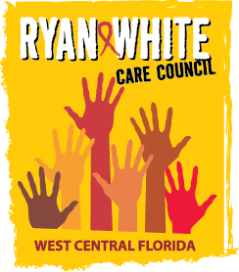
WEST CENTRAL FLORIDA RYAN WHITE CARE COUNCIL
RESOURCE PRIORITIZATION AND ALLOCATION RECOMMENDATIONS
GOTOWEBINAR
THURSDAY, DECEMBER 10, 2020
11:00 A.M. - 12:30 P.M.

AGENDA

- Call to Order Chair

- Roll Call Staff

- Changes to Agenda Members

IV. Adoption of Minutes Chair
October 8, 2020 (Attachment)

V. Care Council Report Co-Chair

VI. Recipient Update Arnold

VII. Lead Agency Update Everhart
- Part B Expenditure Report

VIII. Community Input/Announcements Members

IX. Adjournment Chair

Note: Items in bold are action items.

The Ryan White Care Council’s next meeting will be January 6, 2020 from 1:30pm to 3:30pm, by way of GoToWebinar

The CARE COUNCIL website is at www.thecarecouncil.org.
Meeting information, agendas and minutes will be posted on this website.

