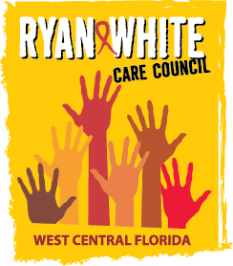
WEST CENTRAL FLORIDA RYAN WHITE CARE COUNCIL
RESOURCE PRIORITIZATION AND ALLOCATION RECOMMENDATIONS
GOTOWEBINAR
THURSDAY, AUGUST 13, 2020
11:00 A.M. - 12:30 P.M.

AGENDA

- Call to Order Chair

- Roll Call Staff

- Changes to Agenda Members

IV. Adoption of Minutes Chair
July 9, 2020 (Attachment)

V. Care Council Report Co-Chair

VI. Recipient Update Arnold

VII. Part A Expenditure Report

IX. Lead Agency Update Everhart

X. Part B Expenditure Reports Everhart

XI. Community Input/Announcements Members

XII. Adjournment Chair

Note: Items in bold are action items.

The Ryan White Care Council’s next meeting will be September 2, 2020 from 1:30pm to 3:30pm, by way of GoToWebinar.

The CARE COUNCIL website is at www.thecarecouncil.org. Meeting information, agendas and minutes will be posted on this website.

