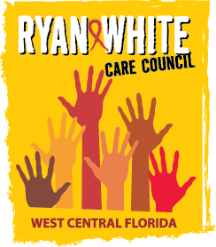
WEST CENTRAL FLORIDA RYAN WHITE CARE COUNCIL
RESOURCE PRIORITIZATION AND ALLOCATION RECOMMENDATIONS
GOTOWEBINAR
THURSDAY, SEPTEMBER 10, 2020
11:00 A.M. - 12:30 P.M.

AGENDA

- Call to Order Chair

- Roll Call Staff

- Changes to Agenda Members

IV. Adoption of Minutes Chair
August 13, 2020 (Attachment)

V. Care Council Report Co-Chair

VI. Recipient Update Arnold

VII. Lead Agency Update Everhart

VIII. Part B FY 19-20 Close-Out Expenditure Report Everhart

IX. Annual Committee Updates Members
- Committee Location/Date/Time
- 2020-2021 Committee Work Plan (Attachment)
- Chair & Co-Chair Elections (Attachment)

X. Assessment of the Administrative Mechanism (AAM) Cavalleri

XI. Community Input/Announcements Members

XII. Adjournment Chair

Note: Items in bold are action items.

The Ryan White Care Council’s next meeting will be October 7, 2020 from 1:30pm to 3:30pm, by way of GoToWebinar.

The CARE COUNCIL website is at www.thecarecouncil.org. Meeting information, agendas and minutes will be posted on this website.

